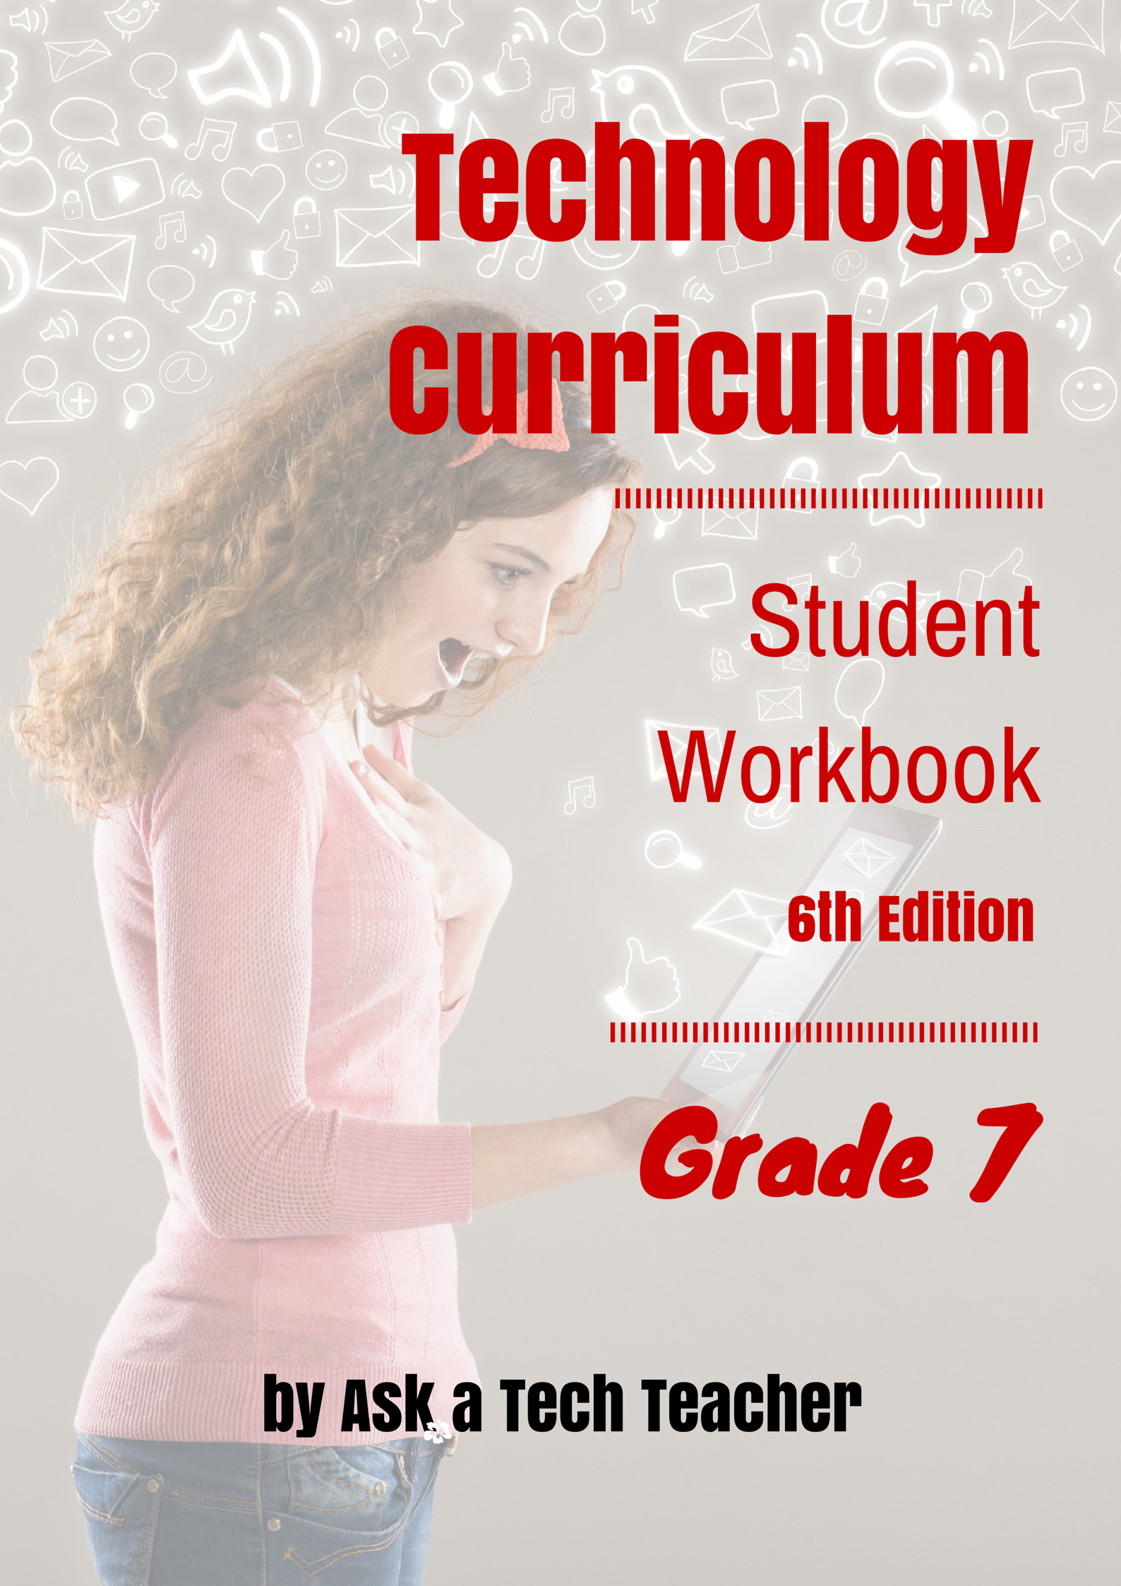

TECHNOLOGY Curriculum
Student Workbook

Seventh Grade

Sixth Edition

By Ask a Tech Teacher©

Part Eight of Nine in the SL Technology Curriculum

Sixth Edition 2016

ALL MATERIAL IN THIS BOOK IS PROTECTED BY THE INTELLECTUAL PROPERTY LAWS OF THE USA.

No part of this work can be reproduced or used in any form or by any means—graphic, electronic, or mechanical, including photocopying, recording, taping, Web distribution or information storage and retrieval systems—without the prior written permission of the publisher
2016© Structured Learning LLC. All Rights Reserved

For permission to use material from this text or product, contact us by email at:
info@structuredlearning.net
structuredlearning.net

ISBN 978-1-942101-13-0

Printed in the United States of America
Introduction

Technology in your classroom—what an exciting way to enhance your learning! You won’t be memorizing tools and struggling through new programs. You’ll learn them as you use them—authentically, part of class activities. Your goal: Make school easier, more relevant, and more in tune with how you learn. We’re going to help. All you need to do is follow this workbook.

How much time will that take? Here’s an estimate:

Grades K-2 15-30 min. a week
Grades 3-8 30-60 min. a week

Are you surprised you can learn so much in such a short time? Wait till you see how much fun it is! We give you lots of choices. You can even work with a friend, both of you on laptops, Chromebooks, iPads (sometimes) or desktops, Windows or Macs.

Here’s where you’re headed (Figure 1):

Figure 1—Tomorrow's student
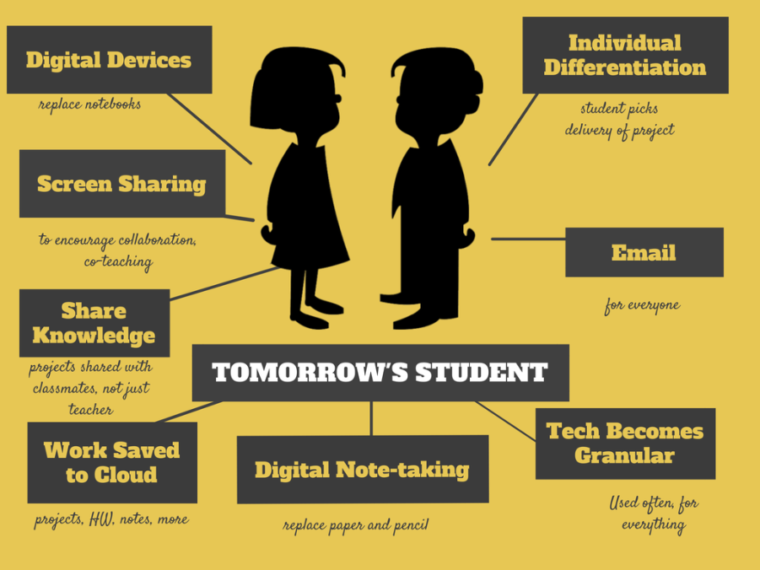

Follow the plan. Execute it faithfully. It works.
Programs You’ll Use

Programs used in this curriculum focus on those that serve the fullness of your educational journey. Free alternatives are included where possible:
General |  | K-2
Email | Drawing tools | Productivity tools (Office, Google Docs)
Google Earth | Keyboard tools | Desktop publishing tools
Web tools |  | Photo editing tool(s)

What’s in this Workbook?

Each lesson includes:

- activities to extend lessons
- class exit ticket
- class warm-up
- essential question
- examples, rubrics, images, printables
- problem solving
- skills—new and scaffolded
- steps to accomplish goals
- suggestions based on digital device
- supporting links
- to-do list
- vocabulary used

Figures 2a-b shows what comes at the beginning of each lesson and the end (zoom in if needed):

Figure 2a-b—What's included in each lesson
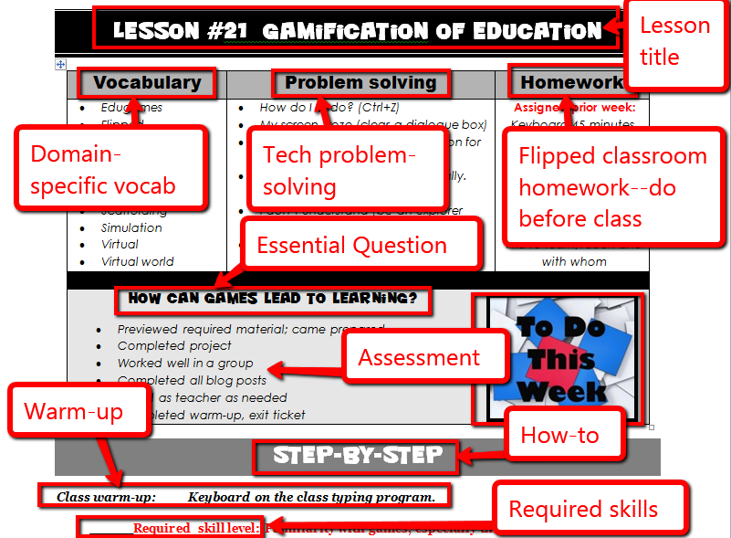
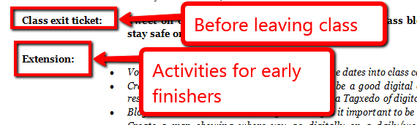
How to Use This Book

Your teacher(s) (meaning: all those who direct your technology training) will work with you during classtime. You’ll spend an additional thirty-sixty minutes each week using your tech skills—online, with software, teaching friends, for homework, and in class projects. If there is a skill you don’t understand, get help, especially when you see it come up a second or third time. By the end of 8th grade, you’ll have a well-rounded tech education that prepares you for college and career.

The curriculum map (Figure 3) shows what’s covered in which grade. Units taught multiple years reflect increasingly less scaffolding and more student direction. Here’s how to use it:

- Determine what skills were covered in earlier years. Transfer that knowledge to this new school year. Your teacher will review the topics and skills from prior years, but won’t re-teach.

Figure 3—Curriculum Map—K-8
 | Mouse Skills | Vocabulary  - Hardware | Problem-solving | Platform | Keyboard | WP | Slide-shows | DTP | Spread-  sheet | Google Earth | Search/  Research | Graphics/ | Co-  ding | WWW | Games | Dig  Cit
K | ☺ | ☺ | ☺ | ☺ | ☺ |  |  |  |  | ☺ |  | ☺ | ☺ | ☺ |  | ☺
1 | ☺ | ☺ | ☺ | ☺ | ☺ | ☺ | ☺ | ☺ | ☺ | ☺ |  | ☺ | ☺ | ☺ |  | ☺
2 |  | ☺ | ☺ | ☺ | ☺ | ☺ | ☺ | ☺ | ☺ | ☺ |  | ☺ | ☺ | ☺ |  | ☺
3 |  | ☺ | ☺ | ☺ | ☺ | ☺ | ☺ | ☺ | ☺ | ☺ | ☺ | ☺ | ☺ | ☺ |  | ☺
4 |  | ☺ | ☺ |  | ☺ | ☺ | ☺ | ☺ | ☺ | ☺ | ☺ | ☺ | ☺ | ☺ |  | ☺
5 |  | ☺ | ☺ |  | ☺ | ☺ |  | ☺ | ☺ | ☺ | ☺ | ☺ | ☺ | ☺ |  | ☺
6 |  | ☺ | ☺ | ☺ | ☺ | ☺ | ☺ | ☺ | ☺ | ☺ | ☺ | ☺ | ☺ | ☺ |  | ☺
7 |  | ☺ | ☺ | ☺ | ☺ | ☺ |  |  | ☺ | ☺ | ☺ | ☺ | ☺ | ☺ | ☺ | ☺
8 |  | ☺ | ☺ | ☺ | ☺ | ☺ |  |  | ☺ | ☺ | ☺ | ☺ | ☺ | ☺ | ☺ | ☺

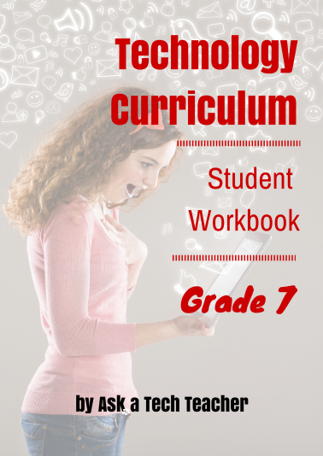
Here are hints on using this curriculum:
Figure 4--Student workbook

- This workbook is part of the K-8 curriculum your school selected to guide you through technology skills. Each lesson takes two sessions of 30-45 minutes with equal time devoted to home practice.
- This curriculum uses the ‘flipped classroom’ approach. Homework prepares you for the class lesson so class time is spent on enrichment. Homework materials will be shared via the class website, blog, Internet start page, as videos, links, or other resources. You will cover the homework material before class, arriving at class prepared to fully participate in activities. If you have any difficulties accessing the homework, talk to your teacher so s/he can help you work that out.
- Every effort has been made to accommodate varied digital devices. Lesson samples are often in multiple platforms. If you have difficulty adapting your digital device to lesson expectations, talk to your teacher.
- You can use this workbook on PCs, Macs, Chromebooks, or iPads. You can use a desktop, laptop, or a netbook.

Figure 5a-h—Digital Devices for workbooks
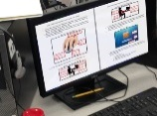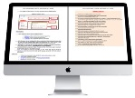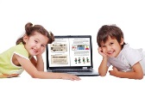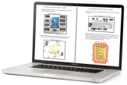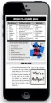

…at school or at home
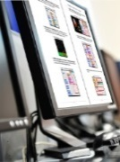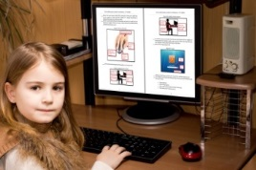

- Check with your teacher on which of these are available with your program license.
- A number of lessons are mixed throughout the year:

#5 Digital Citizenship
#3 Keyboarding
#4 Problem Solving

- Lessons include Extensions, in case you finish early.
- Zoom in or out of workbook pages to get exactly the size that works for your needs.
- Most lessons start with a warm-up to get you into tech.
- Some lessons offer several activities that meet goals outlined in the Essential Question.

- indicates video
- indicates work with a partner
- indicates workbook material

- Always use lesson vocabulary. You gain authentic understanding of terms by using them in conversation.
- Consider backing up your work—as a life habit. This can be done with a flash drive, by emailing the document to yourself, or saving to a secondary location.
- Expect to be a risk taker. Your teacher won’t rush in to solve your problems. Instead, s/he’ll ask you to think how it was done in the past. Don’t be afraid of failing. That often precedes success.
- Lessons expect you to develop ‘habits of mind’ (Figure 6). In a sentence: Habits of Mind ask you to engage in learning, not simply memorize. Your teacher will cover this in more depth.
Figure 6—Habits of Mind
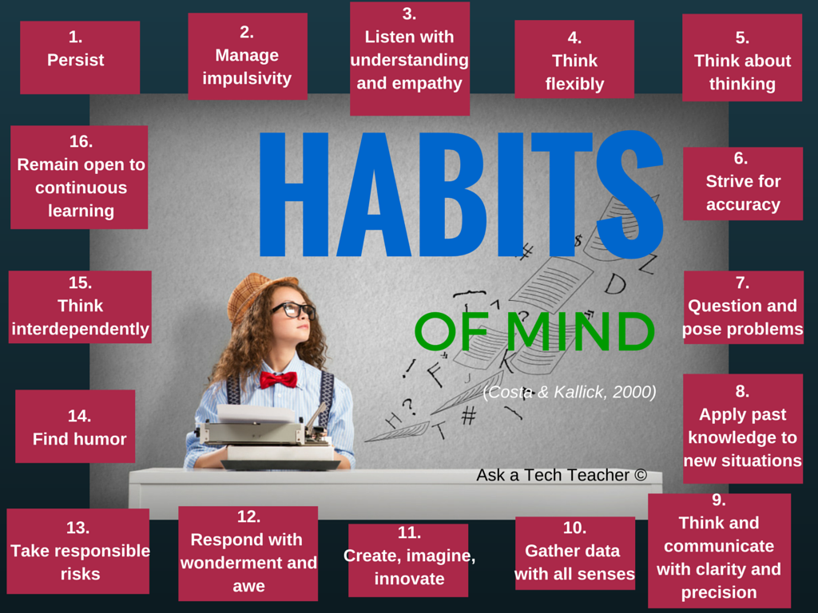

- Each lesson includes a short list of tech problems. Be sure you are able to solve those before leaving the lesson.
- Your teacher will assess your work based on the weekly ‘To Do’ list and the Essential Question. Be sure you’ve completed items and submitted in the manner required.
- If lesson instructions don’t work, ask your teacher for help or email us (with parent and/or teacher approval) at askatechteacher@gmail.com.
- Check off items you finish (using the ______ in front of each task). It’s fine if you don’t get everything done. Return to it when you finish a lesson ahead of time. Use an annotator like iAnnotate, Evernote, OneNote, Notability, or Adobe Reader. Also use these tools to add notes to the lessons.
Figure 7—Tech use plan
- When you finish each lesson, transfer knowledge to projects at school, home, the library, a club—wherever you use digital devices.
- Remember: It takes five times with a skill to get it—

- First: you hope it’ll go away
    - Second: you try it
    - Third: you remember it
    - Fourth: you use it outside of class
    - Fifth: you teach a friend
Copyrights

You have a single-user license on this ebook which means you may reproduce copies of material for your personal use only. You may not reproduce the entire workbook and share it with a friend. Reproduction of any part for others is strictly prohibited. No part of this publication may be transmitted, stored, or recorded in any form without written permission from the publisher.

About the Author

Ask a Tech Teacher is a group of technology teachers who run an award-winning resource blog. Here they provide free materials, advice, lesson plans, pedagogical conversation, website reviews, and more to all who drop by. The free newsletters and website articles help thousands of teachers, homeschoolers, and those serious about finding the best way to maneuver the minefields of technology in education. They have published hundreds of ebooks, workbooks, articles, and have materials shared throughout the world.

Table of contents

Introduction

What’s in This Workbook?

How to Use This Book

Table of Images

Table of Assessments

Lessons

#1 Introduction
#2 Digital Tools in Class
#3 Keyboarding
#4 Problem Solving
#5 Digital Citizenship
#6 Word Processing Options
#7 Spreadsheets
#8-9 Google Earth
#10-11 Online Image Legalities
#12 Internet Search/Research
#13-16 Robotics
#17-20 Coding/Programming
#21 Gamification of Education
#22-24 Web Comm. Tools
#25-28 Differentiated Learning
#29-30 Writing/Publishing an Ebook
#31-32 Making an Ebook Trailer

Arranged by theme:

Basics

#1 Introduction
#2 Digital Tools in Class
#3 Keyboarding
#6 Word Processing Options
#7 Spreadsheets

Logical Thinking

#4 Problem Solving
#13-16 Robotics
#17-20 Coding/Programming
#21 Gamification of Education

Digital Citizenship
#1 Intro
#2 Digital Tools in Class
#5 Digital Citizenship
#10-11 Online Image Legalities
#12 Internet Search/Research

#22-24 Web Communication Tools

Writing
#6 Word Processing Options
#8-9 Google Earth
#12 Internet Search/Research
#25-28 Differentiated Learning
#29-30 Writing/Publishing an Ebook
#31-32 Making an Ebook Trailer

Problem Solving

#4 Problem solving
#17-20 Coding/Programming
#21 Gamification of Education
#25-28 Differentiated Learning

Table of Images

Figure 1—Tomorrow's student 4
Figure 2a-b—What's included in each lesson 5
Figure 3—Curriculum Map—K-8 6
Figure 4--Student workbook 6
Figure 5a-h—Digital Devices for workbooks 7
Figure 6—Habits of Mind 8
Figure 7—Tech use plan 8
Figure 8a-b—Which image represents 'technology'? Error! Bookmark not defined.
Figure 9—Class rules Error! Bookmark not defined.
Figure 10—Digital citizenship poster Error! Bookmark not defined.
Figure 11—How to hold a mouse 18
Figure 12a-d—Digital devices and their parts 18
Figure 13a—Parts of iPad; 13b—Chromebook 19
Figure 14a—iAnnotate; 14b—Notability; 14c—Adobe Acrobat 25
Figure 15a-d—Avatars 26
Figure 16a-c—Backchannel devices 26
Figure 17a-c—Student blogs 27
Figure 18a—Digital blog; 18b—handwritten blog 27
Figure 19a—Blogging rules; 19b—blogging rubric 28
Figure 20—Blog privacy 28
Figure 21a—Class calendar in Google; 21b—Padlet; 21c—DTP 29
Figure 22a—Class start page in Protopage; 22b--Symbaloo; 22c—Portaportal; 22d—LiveBinders 29
Figure 23—Twitter—private account 30
Figure 24a-b—Social media safety 30
Figure 25a-b—Notetaking tools 31
Figure 26—Collaborative notes in Google Spreadsheets 32
Figure 27a—Evernote; 27b—Twitter 32
Figure 28a—Wiki; 28b—Google Drive 33
Figure 29—Homework dropbox 33
Figure 30—Email etiquette 34
Figure 31a—Evidence Board; 31b—Badge 35
Figure 32--What is a flipped classroom? 36
Figure 33a—Blendspace; 33b—Flipped classroom 36
Figure 34—How to log in 37
Figure 35—Track UN and PW 37
Figure 36a—Screenshot to explain log-in; 36b—to explain screencasts 38
Figure 37—Student website rubric 39
Figure 38--Why learn to keyboard? Error! Bookmark not defined.
Figure 39a—Keyboarding posture; 39b—position Error! Bookmark not defined.
Figure 40—Keyboarding hand position Error! Bookmark not defined.
Figure 41--Shortkeys Error! Bookmark not defined.
Figure 42a—iPad shortkeys; 42b—Chromebook shortkeys; 42c—PC shortkeys; 42d—Internet shortkeys Error! Bookmark not defined.
Figure 43a-e—Project-based learning and keyboarding Error! Bookmark not defined.
Figure 44a-k—Projects that use keyboarding in 7th grade Error! Bookmark not defined.
Figure 45--Why is key placement important? Error! Bookmark not defined.
Figure 46—Important keys on keyboard Error! Bookmark not defined.
Figure 47a—Blank keyboard quiz for PCs; 47b—for Chromebook Error! Bookmark not defined.
Figure 48—Problem-solving quotes 50
Figure 49—How to solve a problem 51
Figure 50—Common tech problems 51
Figure 51—Common tech problems 55
Figure 52--When no one watches Error! Bookmark not defined.
Figure 53—Digital Citizenship topics Error! Bookmark not defined.
Figure 54a—Netiquette Rules; 54b—Digital pyramid Error! Bookmark not defined.
Figure 55a-d—Word processing examples 1st-6th grade Error! Bookmark not defined.
Figure 56—Compare/contrast B Error! Bookmark not defined.
Figure 57—Tools on toolbars Error! Bookmark not defined.
Figure 58a-c—Examples of outlines in word processing programs Error! Bookmark not defined.
Figure 59a—MS Word; 59b—Google Docs Error! Bookmark not defined.
Figure 60--Twitter novel sample Error! Bookmark not defined.
Figure 61--Serialized novel by Conrad Error! Bookmark not defined.
Figure 62a-c—Comic samples Error! Bookmark not defined.
Figure 63—Decoding a comic strip Error! Bookmark not defined.
Figure 64—Blank comic template Error! Bookmark not defined.
Figure 65a-d—Writing with Art K-6 Error! Bookmark not defined.
Figure 66a-e—Drawing tools Error! Bookmark not defined.
Figure 67a-f—DTP project from 2nd-6th Error! Bookmark not defined.
Figure 68a-b—Compare-contrast report covers Error! Bookmark not defined.
Figure 69a-d—Writing with slideshows Error! Bookmark not defined.
Figure 70a-f—Projects with spreadsheets Error! Bookmark not defined.
Figure 71a-b—Drawing with spreadsheets Error! Bookmark not defined.
Figure 72--Typing posture Error! Bookmark not defined.
Figure 73a-c—Spreadsheet projects Error! Bookmark not defined.
Figure 74—Compare/contrast E Error! Bookmark not defined.
Figure 75a-b—Two formulae Error! Bookmark not defined.
Figure 76—Excel formulae Error! Bookmark not defined.
Figure 77a-b—Formula unpacked Error! Bookmark not defined.
Figure 78a-e—Prior Google Earth projects Error! Bookmark not defined.
Figure 79—Google Earth: Siege of Vicksburg Error! Bookmark not defined.
Figure 80—Google Earth: Emancipation Proclamation Error! Bookmark not defined.
Figure 81—Google Earth: Sherman's March Error! Bookmark not defined.
Figure 82—Google Earth: Surrender at Appomattox Error! Bookmark not defined.
Figure 83a—Placemark dialogue box in GE; 83b—in Google Maps Error! Bookmark not defined.
Figure 84a—Overlay in ScribbleMaps; 84b in Google Earth Error! Bookmark not defined.
Figure 85—Mini tour placemark Error! Bookmark not defined.
Figure 86—Digital law—rephrased 57
Figure 87—Copyright protections on browsers 57
Figure 88—Two copyrighted images 58
Figure 89a-b—Creative Commons licensing 58
Figure 90a-b—Artistic work online 59
Figure 91—Definition of 'fair use' 59
Figure 92a-b: Add or remove pieces from a photo 60
Figure 93—Real or a hoax? 60
Figure 94a-c—Real or hoax pictures? 61
Figure 95--Steps for internet research Error! Bookmark not defined.
Figure 96—Sample search Error! Bookmark not defined.
Figure 97—Search tips Error! Bookmark not defined.
Figure 98—What are the parts of a website? Error! Bookmark not defined.
Figure 99—Research skills Error! Bookmark not defined.
Figure 100—More search tips Error! Bookmark not defined.
Figure 101—Reason abstractly Error! Bookmark not defined.
Figure 102—Construct viable arguments Error! Bookmark not defined.
Figure 103a—Robot brain; 103b—Completed robot Error! Bookmark not defined.
Figure 104—Robotic pieces Error! Bookmark not defined.
Figure 105—Programming robot Error! Bookmark not defined.
Figure 106—Robot script Error! Bookmark not defined.
Figure 107a-b—Programming robot Error! Bookmark not defined.
Figure 108a-b—Screen where robot tells you what's going on Error! Bookmark not defined.
Figure 109—Find programs on the NXT Error! Bookmark not defined.
Figure 110a-b—Completed robots Error! Bookmark not defined.
Figure 111—Robot tasks Error! Bookmark not defined.
Figure 112a-b—Bot Battles Error! Bookmark not defined.
Figure 113—Tournament Elimination Poster Error! Bookmark not defined.
Figure 114a-b—Blogs about robotics Error! Bookmark not defined.
Figure 115a-b—What programming feels like vs. what it is Error! Bookmark not defined.
Figure 116a-e—Coding from previous years Error! Bookmark not defined.
Figure 117—Make sense of problems Error! Bookmark not defined.
Figure 118—Reason quantitatively Error! Bookmark not defined.
Figure 119—Critique the reasoning of others Error! Bookmark not defined.
Figure 120a and 120b—Model with mathematics Error! Bookmark not defined.
Figure 121—Use appropriate tools strategically Error! Bookmark not defined.
Figure 122—Attend to precision Error! Bookmark not defined.
Figure 123—Make use of structure Error! Bookmark not defined.
Figure 124a and 124b—Regularity in repeated reasoning Error! Bookmark not defined.
Figure 125—Scratch program page Error! Bookmark not defined.
Figure 126a-b—Scratch script and result Error! Bookmark not defined.
Figure 127a-b—Scratch remix Error! Bookmark not defined.
Figure 128—Scratch program Error! Bookmark not defined.
Figure 129—Scratch Sprites Error! Bookmark not defined.
Figure 130—Scratch dialogue Error! Bookmark not defined.
Figure 131—Scratch ending Error! Bookmark not defined.
Figure 132—Scratch embed Error! Bookmark not defined.
Figure 133a-b—Blog post about Scratch Error! Bookmark not defined.
Figure 134—Wolfram/Alpha widget Error! Bookmark not defined.
Figure 135a-b—Wolfram/Alpha completed widget; 135c—embedded in blog Error! Bookmark not defined.
Figure 136—Alice Error! Bookmark not defined.
Figure 137—Animoto Error! Bookmark not defined.
Figure 138—BigHugeLabs Error! Bookmark not defined.
Figure 139—Bubbl.us Error! Bookmark not defined.
Figure 140—Class Tools Error! Bookmark not defined.
Figure 141—Comic Creator Error! Bookmark not defined.
Figure 142—Puzzle creator Error! Bookmark not defined.
Figure 143—Diagrams Online Error! Bookmark not defined.
Figure 144—Equiz Error! Bookmark not defined.
Figure 145—GIF creator Error! Bookmark not defined.
Figure 146—Glogster Error! Bookmark not defined.
Figure 147—Go Animate! Error! Bookmark not defined.
Figure 148—Google MapMaker Error! Bookmark not defined.
Figure 149—Jing screenshot Error! Bookmark not defined.
Figure 150—PollDaddy Error! Bookmark not defined.
Figure 151—Prezi Error! Bookmark not defined.
Figure 152—QR codes Error! Bookmark not defined.
Figure 153—Shelfari Error! Bookmark not defined.
Figure 154—Slideshows Error! Bookmark not defined.
Figure 155—Tagxedo Error! Bookmark not defined.
Figure 156—Timelines Error! Bookmark not defined.
Figure 157—VoiceThread Error! Bookmark not defined.
Figure 158—Voki Error! Bookmark not defined.
Fig. 159a—Visual organizers in 1st grade; 159b—2nd grade;159c—3rd grade; 159d—4th grade; 159e—6th grade Error! Bookmark not defined.
Figure 160—Differentiated communication with ScribbleMaps Error! Bookmark not defined.
Figure 161—A chart to visually represent info Error! Bookmark not defined.
Figure 162a-e—More visual organizers from K-6 Error! Bookmark not defined.
Figure 163—Mindmap for project Error! Bookmark not defined.
Figure 164a—Timeline using Google Draw; 164b-Data communication using Voki Error! Bookmark not defined.
Figure 165—Book trailer in Animoto Error! Bookmark not defined.

Table of Assessments

Assessment 1—Parts of the computer 41
Assessment 2—Parts of the smartphone 42
Assessment 3—Parts of an iPad 43
Assessment 4—Chromebook parts 44
Assessment 5—Student blogging agreement 45
Assessment 6—Blog grading rubric 46
Assessment 7—Website grading rubric 47
Assessment 8—Digital portfolio rubric 48
Assessment 9—Keyboarding technique checklist Error! Bookmark not defined.
Assessment 10—Important keys Error! Bookmark not defined.
Assessment 11—Blank keyboard quiz Error! Bookmark not defined.
Assessment 12—Chromebook blank keyboard quiz Error! Bookmark not defined.
Assessment 13—Keyboarding Challenge Error! Bookmark not defined.
Assessment 14a-b—Problem-solving authentic data 52
Assessment 15—Problem-solving Presentation Assessment 54
Assessment 16—Compare-contrast tools Error! Bookmark not defined.
Assessment 17—Evaluate writing options Error! Bookmark not defined.
Assessment 18—Word processing summative Error! Bookmark not defined.
Assessment 19—Compare-contrast tools Error! Bookmark not defined.
Assessment 20—Spreadsheet summative Error! Bookmark not defined.
Assessment 21—Spreadsheet summative Error! Bookmark not defined.
Assessment 22—Civil War Google Earth assessment Error! Bookmark not defined.
Assessment 23—Google Earth tour storyboard Error! Bookmark not defined.
Assessment 24—Research skills Error! Bookmark not defined.
Assessment 25—Am I Ready? Error! Bookmark not defined.
Assessment 26—Web-based Communication Tools Error! Bookmark not defined.

Lesson #2 Digital Tools in Class

Vocabulary | Problem solving | Homework
- Annotation  - App  - Backchannel  - Benchmark  - Blog  - Chrome  - Cloud  - Digital portfolio  - Digital tools  - Domain-specific  - Hashtag  - Linkback  - PDF  - Plagiarism  - Template | - I’m too young for Twitter (use class account)  - Avatar didn’t show in my blog (ask a neighbor how they did it)  - My work disappeared (Google Apps automatically saves; or, Ctrl+Z)  - Teacher isn’t around and I need help (get peer support or use student forum)  - Just give me a handout (Sorry, we learn through experience and collaboration)  - Can’t find annotation tool (ask friend)  - I’m not fast enough decoding vocabulary (keep at it—it gets easier)  - I forgot my Evidence (you’ll have a chance every month) | Assigned prior week:  Preview tech tools Know how to log in from home/school (if appropriate)  Practice keyboarding for 45minutes, 15 minutes at a time
How do I use technology to learn?

- Previewed required material; came prepared
- Completed warm-up and exit ticket
- Joined classroom conversations
- [tried to] solve own problems
- Decisions followed class rules
- Habits of mind observed
- Successfully annotated workbook
- Left station as it was (neat and orderly)
Step-by-step

Class warm-up: Test digital tool accounts while waiting for class to start

______Required skill level: Basics
______Any questions from homework? Always come to class prepared.
______Discuss results of interest poll (Exit Ticket from Lesson #1).
______Discuss digital tools in general terms. What are they? How are they different from software and/or apps? Which ones have you used? Why are they mainstays in education? How about:
- to facilitate collaborative work
- to easily publish and share a project with classmates
- to communicate with multiple audiences easily
- to enable the use of a wide variety of media and formats
- to encourage cultural understanding and global awareness
- to provide options (for example: for communication—email, forums, blogs)
- to provide access from anywhere with an Internet connection

______This Digital Tools unit has three expected learning outcomes:

            - introduce digital tools used in 7th grade
            - acclimate you to the concept that tech tools enable differentiation, collaboration, sharing, and publishing
            - show how to employ them in your educational endeavors
______First: Have neighbor’s check each other’s mouse hold (see Figure 11—zoom in if needed):

Figure 8—How to hold a mouse
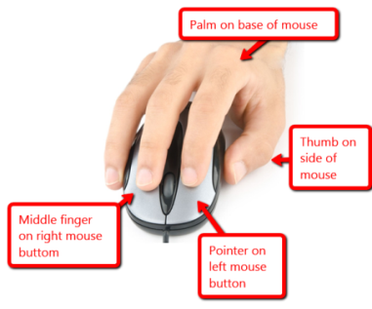
______Review school digital devices. You should know the basic parts and whether they’re input or output. Figures 12a-d are assessments at the end of this lesson. They can be filled out in your workbook (your teacher might want you to send her/him a screenshot). Figures 13a-b are sample completed worksheets (zoom in if necessary).

Figure 9a-d—Digital devices and their parts
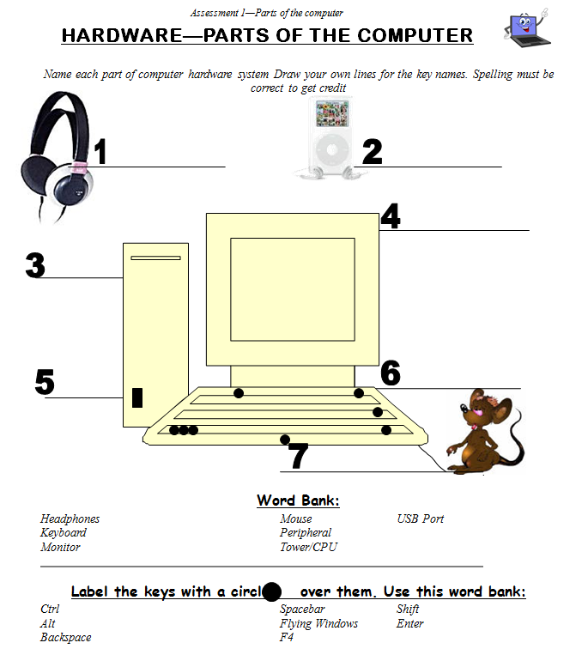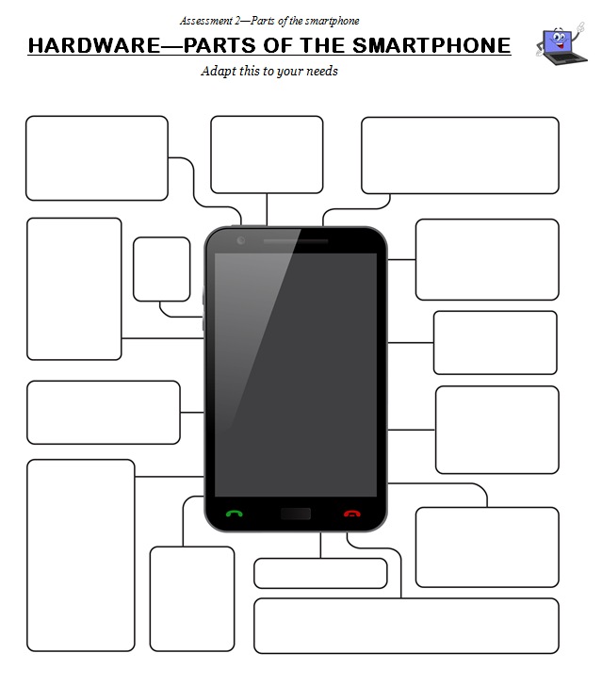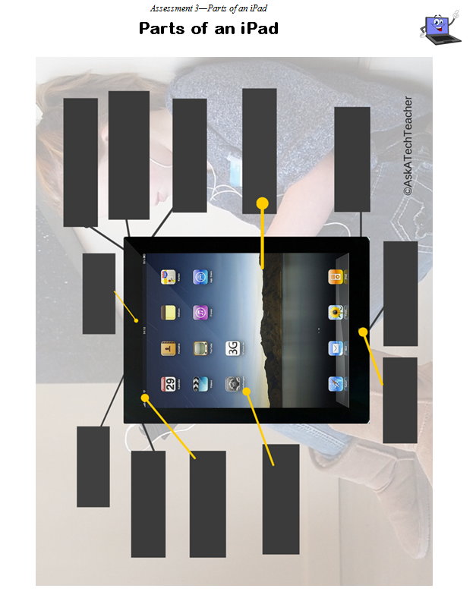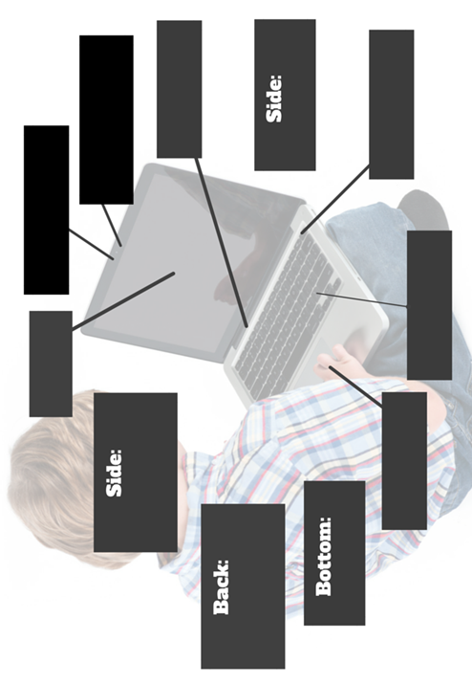

______Review these with a neighbor. For example, if you use iPads, where are the headphones? Or the mouse? How about the USB Port? Where is the microphone on, say, the PC or Chromebook. How about the charging dock?
Figure 10a—Parts of iPad; 13b—Chromebook
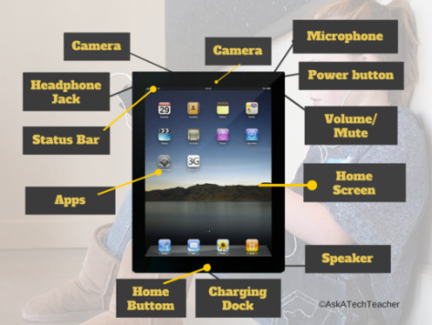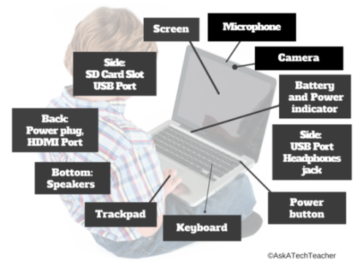

______Discuss how understanding hardware helps to solve tech problems.
______The following tools are discussed in this lesson. Your teacher will pick those that apply to you, or add others:

- annotation tool
- avatars
- backchannel devices
- blogs
- class calendar
- class Internet start page
- class Twitter account
- class website
- class webtools
- digital notetaking
- digital portfolios
- dropbox
- email
- Evidence Board
- Flipped classroom
- Google Apps
- screenshots and screencasts
- student websites
- student workbooks
- vocabulary decoding tools

______Adapt them to your digital devices (Chromebooks, PCs, iMac, iPads, or other).

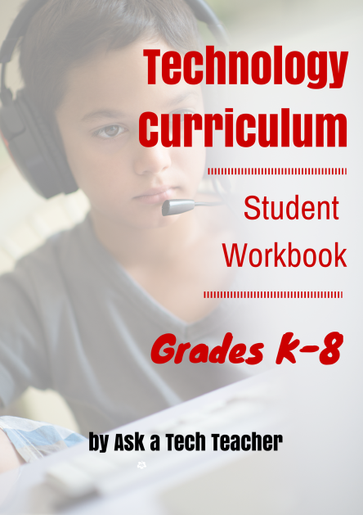
Student workbooks

______Your teacher will introduce your student technology workbook. It includes:

- assessments
- links to websites you’ll use
- links to digital tools used in class
- place to take notes
- full-color samples of projects
- checklists for activities
- extras to extend learning
- ability to circle back on concepts already covered or preview upcoming material

______Experiment with as many of these as you have time for.
Annotation Tool and Screenshots

______Any PDF used in class (such as this workbook) can be annotated with a notetaking tool your school will make available. This might include iAnnotate (Figure 14a), Notability (Figure 14b), or Adobe Acrobat (free—Figure 14c).

Figure 11a—iAnnotate; 14b—Notability; 14c—Adobe Acrobat
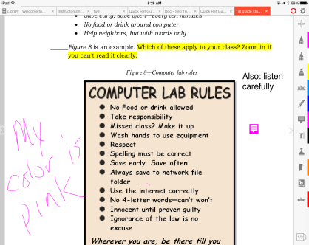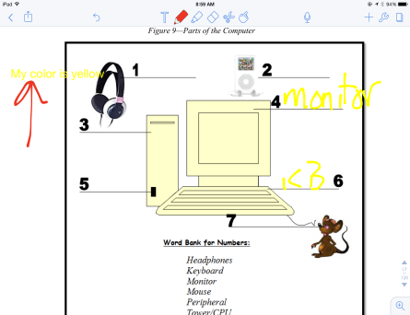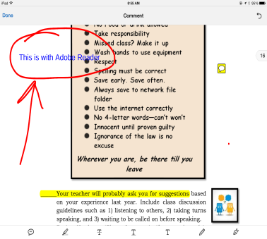

______If you share a PDF (for example, this workbook is loaded on a digital device that multiple students use), select a color different from other students.
______Most digital devices include a built-in annotation tool. This lets you grab a screenshot of your device’s screen, mark it up, and then save or share. This is great for rubrics and other assessments. Here’s a list for common digital platforms:

    - Windows: the Snipping Tool
    - Chromebook: hold down the control key and press the window switcher key
    - Mac: Command Shift 3 to do a full screenshot and Command Shift 4 for a partial
    - Surface tablet: hold down volume and Windows button at the same time
    - iPad: hold Home button and power button at same time
    - Online: a screenshot tool like Jing or Snagit

______Your teacher will review options available in the annotation tool such as:

- highlighting
- text and freeform notes
- screenshots
- sharing/collaborating
- saving to folders

Avatars

______You can create a profile picture with an avatar creator like Figures 15a-d:

- Monster yourself
- Lego you
- Animal yourself
- Madmen yourself
- Voki yourself

Figure 12a-d—Avatars
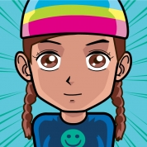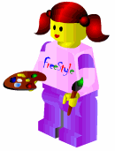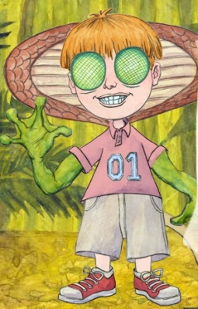

______These can be used in blogs, websites, or any digital platform that requires a profile picture. Use them to reinforce a discussion of digital privacy and safety.

Backchannel Devices

______The ‘backchannel’ is classroom communication that isn’t from the presenter. ‘Backchannel devices’ make it possible for you to share thoughts and ideas, even questions, while a lesson is going on. Typically, the comments show up on the class screen, shared with all classmates, likely anonymously.
______Popular backchannel options are:

- Padlet — a virtual wall; Figure 16a
- Socrative — a closed virtual; Figure 16b
- Today’s Meet — a closed virtual room; Figure 16c
- Twitter — a virtual stream organized by hashtags; private or public

Figure 13a-c—Backchannel devices
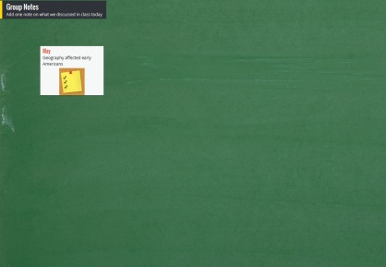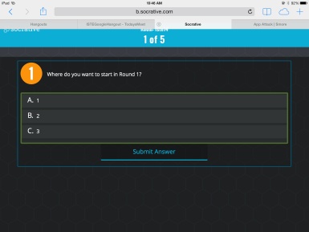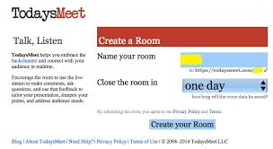

______Here are reasons to use backchannels:

- Everyone gets to contribute, not just the first few to put their hands up.
- You can think before ‘speaking’, making sure you say exactly what you mean.
- You can ask questions without fear.
- You can answer classmate questions.

______Your teacher will introduce the class backchannel, demonstrate how to use it, and let you test it.
Blogs

______Blogs are short online articles that share ideas and garner feedback. In 7th grade, you are particularly interested in the facility to:

  - engage effectively in collaborative discussions with diverse partners
  - build on others’ ideas
  - express your own ideas clearly

______Figures 17a-c are examples of blogs. Notice how they incorporate text and images:

Figure 14a-c—Student blogs
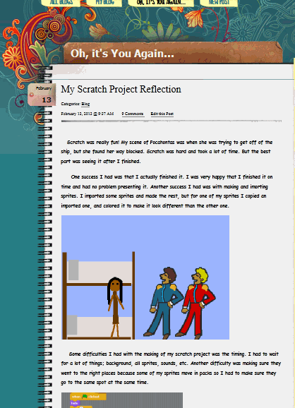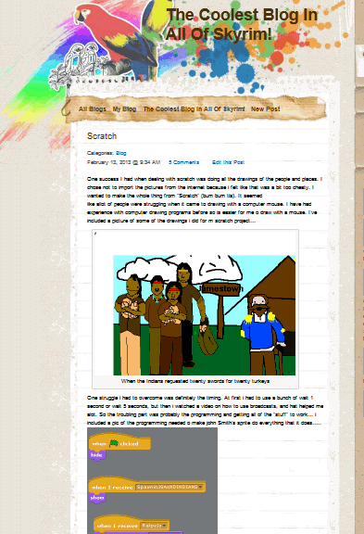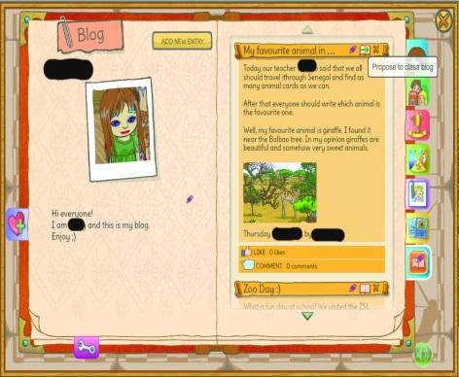

______Which would you prefer to communicate and get ideas on a topic—Figure 18a or 18b?

Figure 15a—Digital blog; 18b—handwritten blog
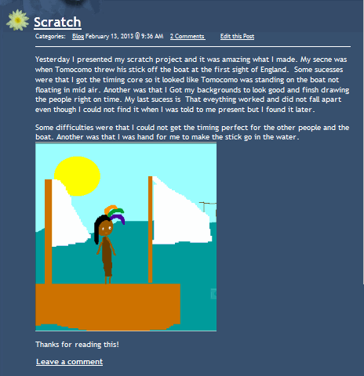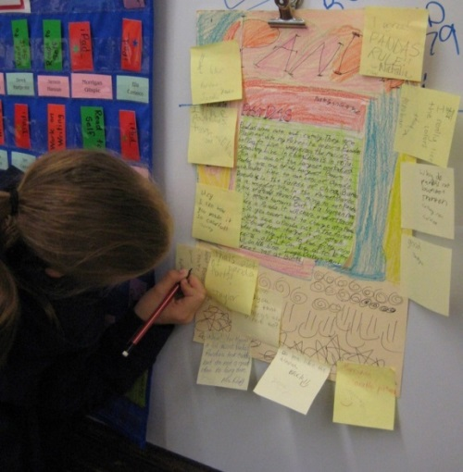

______Blogs reflect your personality with colors, fonts, widgets.
______In general, blogs require:

  - titles that pull reader in
  - tone/voice that fits this type of writing and intended audience
  - linkback(s) to evidence that supports statements
  - at least one medium to support each article (picture, video, sound)
  - understanding of target audience
- understanding of purpose—how is it different from tweets? Essays? Poetry?
- citations—authors name, permission, linkbacks, copyright where required
- occasional teamwork
- pithy conent
- correct spelling and grammar with no slang
______Before blogging, sign an agreement similar to Figure 19a—Seventh Grade Blogging Rules (full size at end of lesson). Discuss the agreement with parents and bring it to school before the next class. These can be signed right in the workbook. Then, take a screenshot and email that to your teacher.

Figure 16a—Blogging rules; 19b—blogging rubric
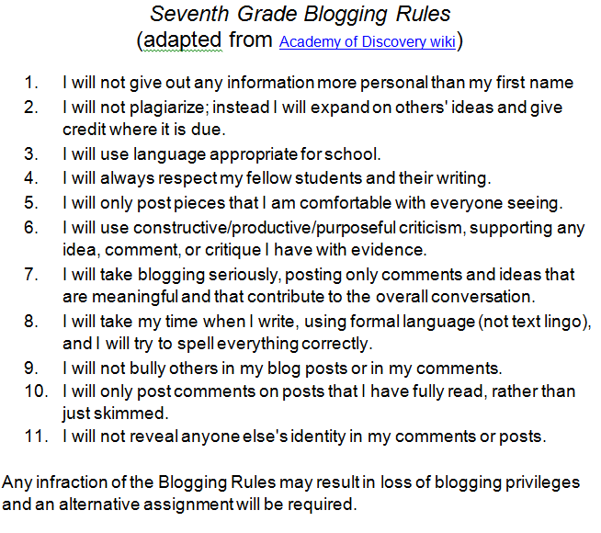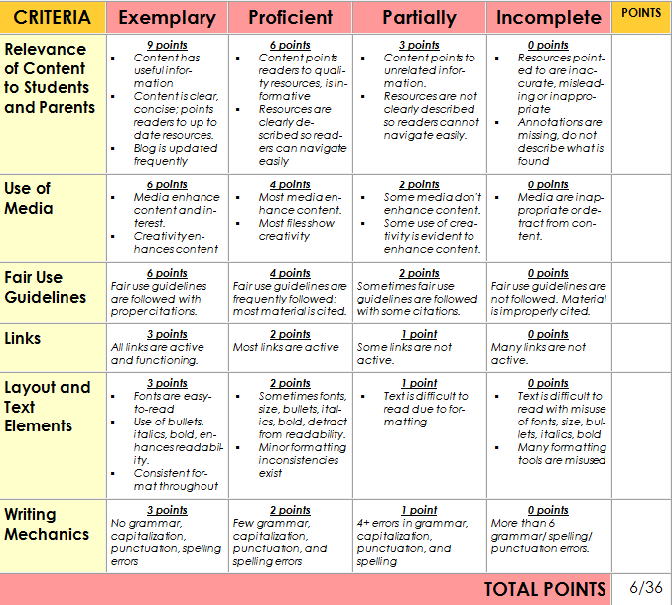

______You can create blogs in Edublogs, Class Blogmeister, and Blogger. They can be public or private.

Figure 17—Blog privacy
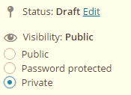

______School blogs are traditionally private, but consider the oxymoron of privacy and the Internet.
______Discuss blogging netiquette—similar to email etiquette:

- be polite
- use good grammar and spelling
- don’t write anything everyone shouldn’t read
______Remember to practice good keyboarding as you type the post.
______Once a month, write on an inquiry topic. Additionally, comment on five classmate blogs.
______If classmate comments aren’t always appropriate, they may require teacher approval before going live. Discuss how supportive comments contribute to the conversation.
______Occasionally throughout the year, expect to have your blog assessed with the Student Blogs Rubric (Figure 19b—full-size assessment at the end of the lesson).

Class Calendar

______You will have a digital class calendar that tracks due dates, class events, and other important information. It might be created in Google Calendar (Figure 21a), Office 365, a Padlet template (Figure 21b), MS Publisher (Figure 21c), or another option. If possible, it will be embedded into the class website. You might also be able to embed it into your blog so that it auto-updates. Check with your teacher on that possibility.
______Volunteer to demonstrate how to edit the calendar by adding homework.
______Volunteer to add events to the calendar for one month. If your teacher allows everyone to contribute, do so responsibly.

Figure 18a—Class calendar in Google; 21b—Padlet; 21c—DTP
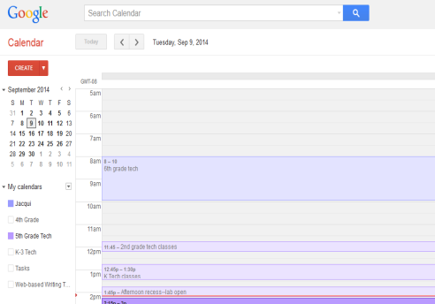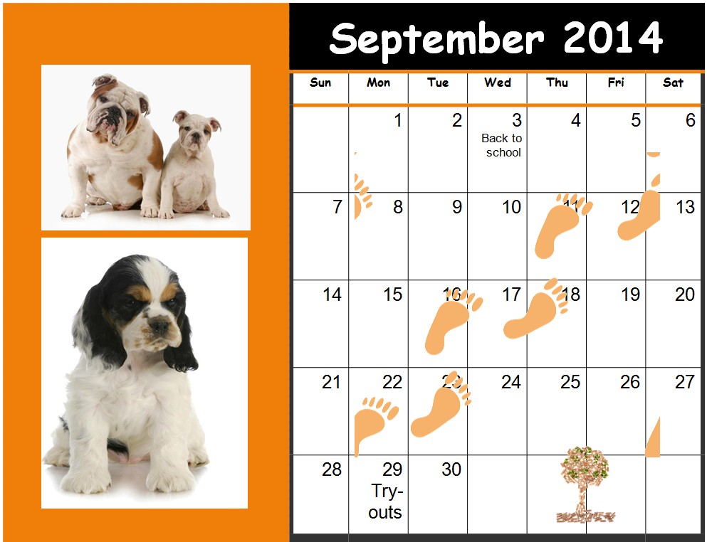

Class Internet Start Page

______A class Internet start page is a website that comes up when you open the Internet. It organizes critical content in a single location and curates links you will use.
______Your class might use Protopage.com (Figure 22a—also shows the type of information you’ll find on an Internet start page), Ighome, or a collection site like Symbaloo (Figure 22b), Portaportal (Figure 22c), LiveBinders (Figure 22d), or a class Diigo account.

Figure 19a—Class start page in Protopage; 22b--Symbaloo; 22c—Portaportal; 22d—LiveBinders
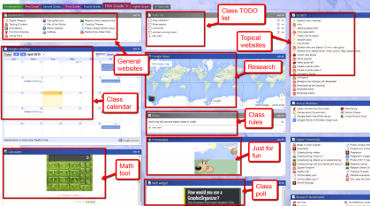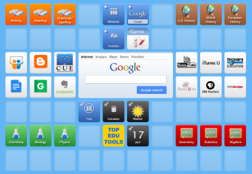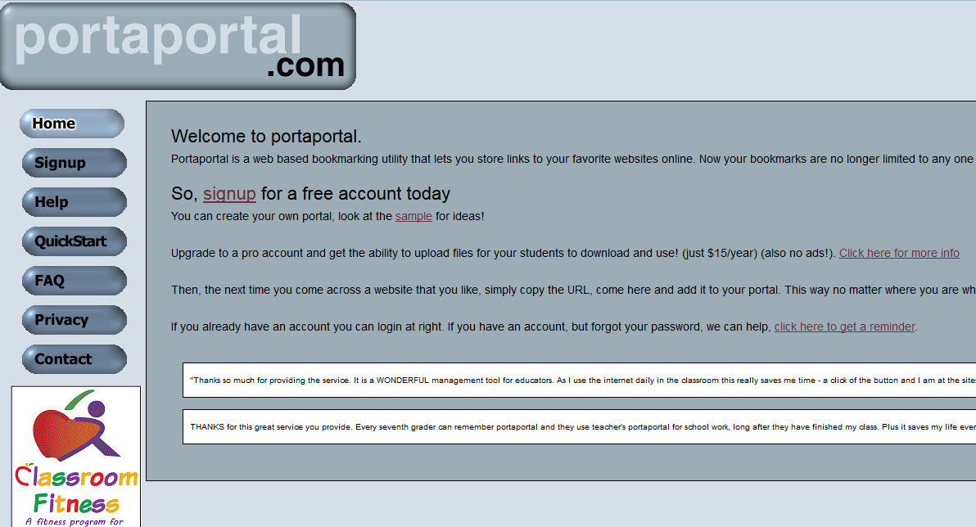

______Remember: Visit the Internet safely and legally. This is discussed in depth in another lesson.
Class Twitter account
______Like blogs and wikis, Twitter feeds are used to:

- engage collaboratively with diverse partners
- review key ideas
- pose questions that elicit elaboration
- acknowledge information from others

______Your class will have a private class twitter account for announcements (see Figure 23), group questions, discussions, and collaboration. Use #hashtags to organize themes like #homework, #math, and #questions.

Figure 20—Twitter—private account
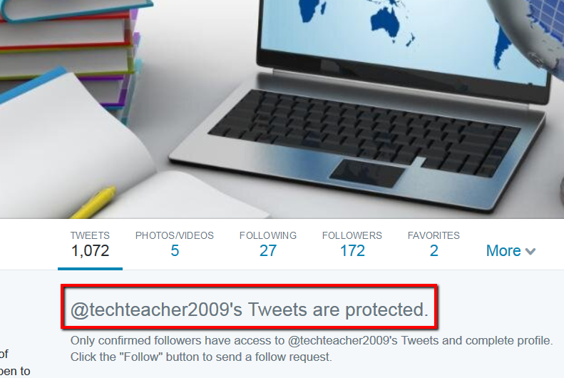

______Most blog and website activity can also be tweeted, so it’s a great redundancy for getting news where it needs to go. But be careful—social networks must be handled right. More on that in lesson on Digital Citizenship.

Figure 21a-b—Social media safety
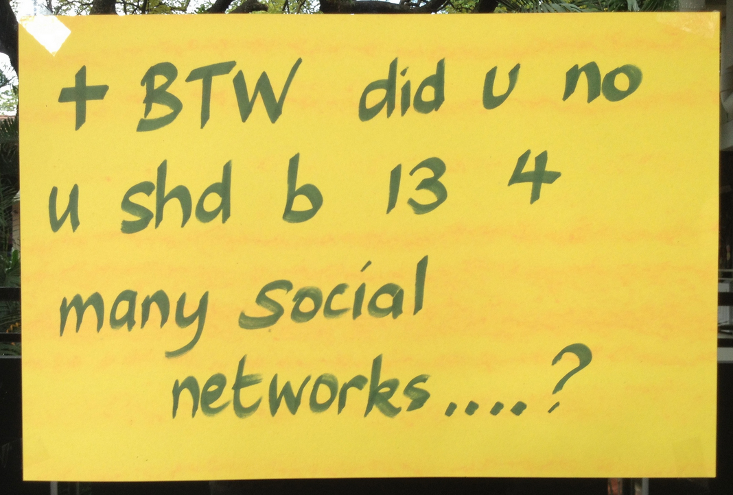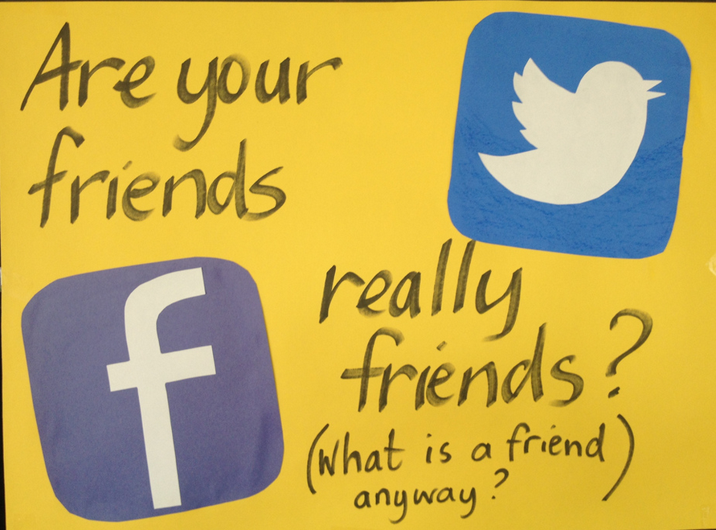
Class website

______Class websites serve as a general resource collection for class information. They are managed by your teacher, including only information that applies to class. There is little opportunity to comment though there may be polls and Discussion Forums.
______Likely, you will have either a class website or a class blog—not both.

Class Webtools

______Class webtools are programs accessed directly from the Internet. They aren’t on the digital device you use at school (though there may be a shortcut to the tool). In fact, if you don’t have an Internet connection, you won’t be able to use them. You’ll like webtools because if you start a project at school, you can finish it at home—no problem.
______Webtools you’ll use to complete projects may include:
- online math program (i.e., Khan Academy)
- digital keyboarding program (i.e., Typing Web)
- avatar creator for digital citizenship
- badge to assess progress
- reading library (like Subtext)

______Log into all class webtools right now to make sure there are no problems.

Digital Notetaking

______Here are five digital notetaking methods you might use (zoom in for how-to notes):

- word processing program (for any digital device) – Figure 25a
- Notability (for iPads) – Figure 25b

Figure 22a-b—Notetaking tools
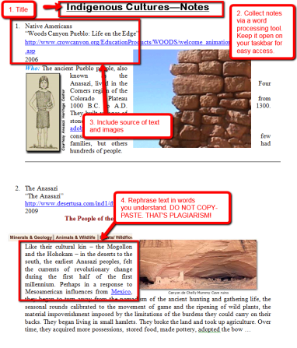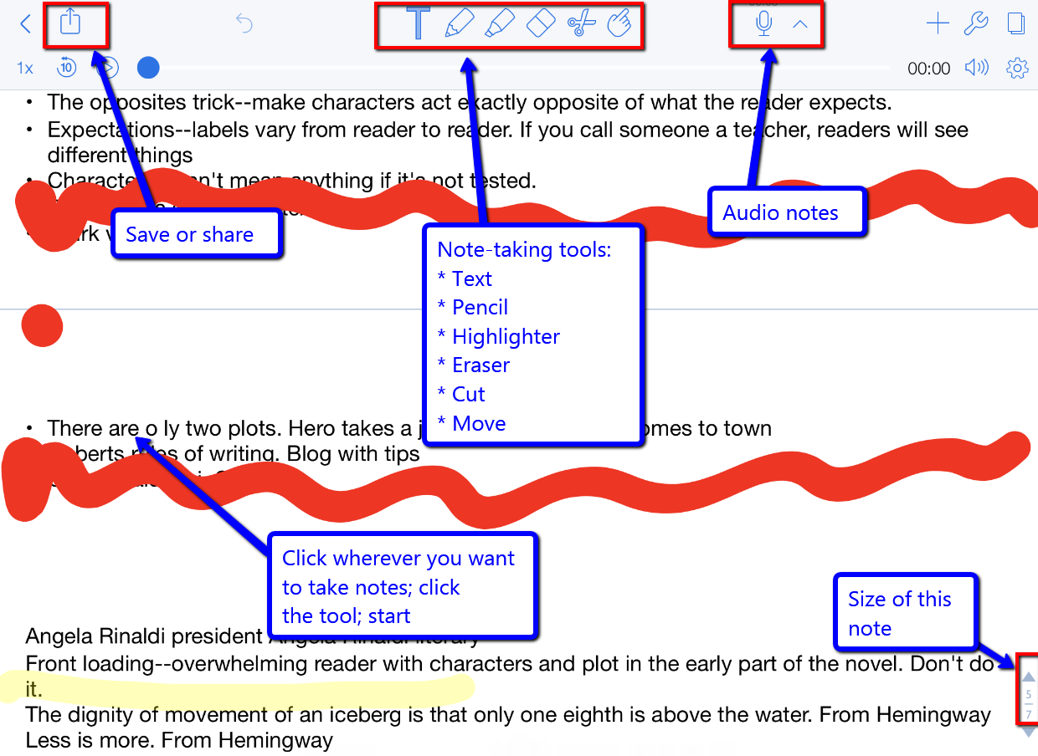
- Google Apps – Figure 26 (zoom in if needed)

Figure 23—Collaborative notes in Google Spreadsheets
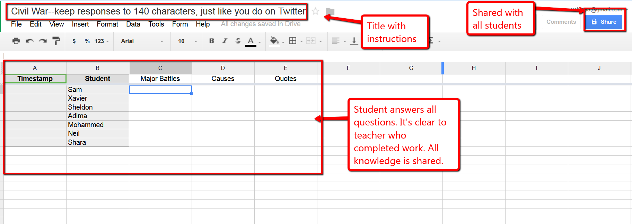

- Evernote/OneNote (for most digital devices) — Figure 27a
- Twitter (for most digital devices) — Figure 27b

Figure 24a—Evernote; 27b—Twitter
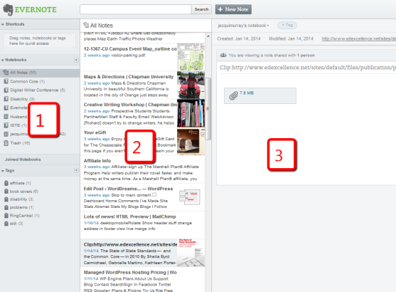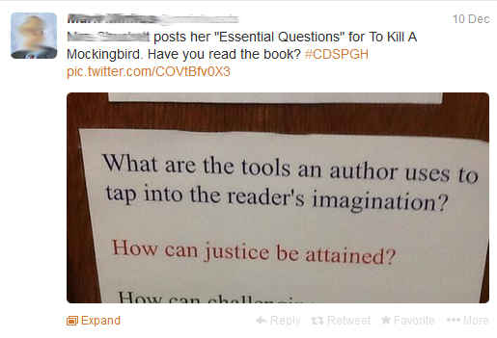

______Here’s why you want to take notes (from Common Core):

- determine central ideas, author’s purpose, and key steps
- provide accurate summary
- cite text evidence to support analysis
- analyze structure used to organize text

Digital portfolios

______Discuss how you have used Digital Portfolios in the past:

- store work (in Cloud) required in other classes or at home
- interact, collaborate, and publish with peers
- edit or review work in multiple locations
- submit class assignments
______There are a variety of digital portfolios that satisfy some or all of the above uses: 1) folders on school network, 2) fee-based programs from companies such as Richer Picture, 3) cloud-based storage like Dropbox or Google Apps (Figure 28b—zoom in if needed), and 4) online collaborative sites like Wikispaces.com (Figure 28a) or PBWorks.com (Google for addresses). Your teacher will tell you which you’ll be using.
______Occasionally, use the Assessment at end of this lesson to review your progress.

Figure 25a—Wiki; 28b—Google Drive
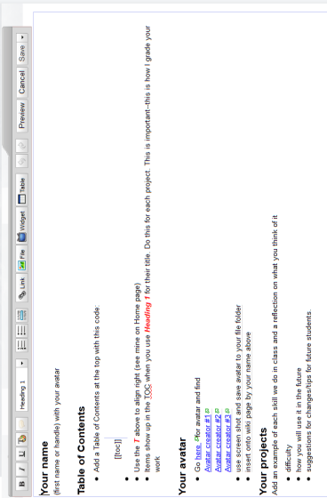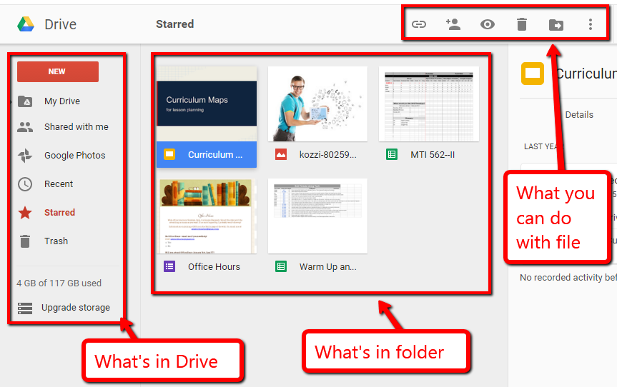

Dropbox
______If your school uses digital dropboxes, your teacher will review them now. It may be through the school Learning Management System (LMS), email, Google Apps (through ‘share’ function) or even a Discussion Board.
______If you don’t have digital dropboxes, your teacher will share the method you’ll use to submit classwork and homework.
______If you have Google Apps, here’s how to create a Homework drop box like Figure 29:

- Create a folder called ‘Homework’ that is shared with your teacher.
- To submit work, copy it to that folder.

Figure 26—Homework dropbox
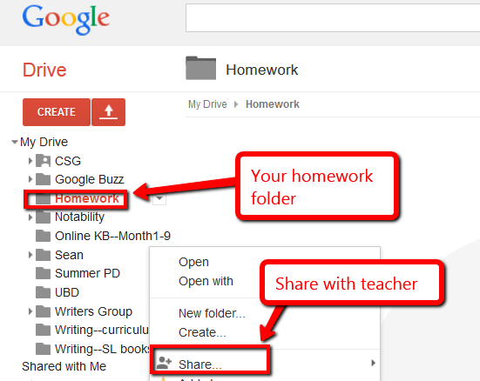
Email

______Use a web-based email account such as Gmail (comes with GAFE and Google Classrooms).
______Review email etiquette (Figure 30):

- Use proper writing conventions.
- CC anyone mentioned.
- Make ‘Subject line’ topic of email.
- Answer swiftly.
- Re-read before sending.
- Don’t use all caps—THIS IS SHOUTING.
- Don’t attach unnecessary files.
- Don’t overuse high priority.
- Don’t email confidential information.
- Don't email offensive remarks.
- Don’t forward chain letters or spam.
- Don’t open attachments from strangers.

Figure 27—Email etiquette
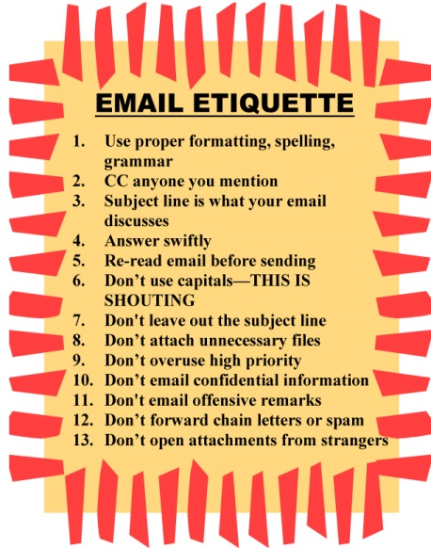

______If you have access to Gmail in GAFE or Google Classroom, your teacher will review how to use the control settings so you don’t get spam.
______Volunteer to clarify terms like ‘high priority’, ‘chain letters’, and ‘CC’.
______Be aware: The email program you use at home may not match the one used at school. Ask your parents to show you how to use the home-based email.
______Why is correct grammar/spelling important in email and not so much with texting? Hint: Consider this Common Core standard: Produce … writing in which development, organization, and style are appropriate to task and audience.
______Discuss how email can be used to back-up important documents (by emailing a copy to yourself or creating a draft email with doc attached and stored in ‘Draft’ file).
______When you get an email, before answering, follow this checklist:

- Do you know sender?
- Is email legitimate? For example, does the ‘voice’ sound like sender?
- Is sender asking for personal information? Legitimate sources never do.
- Is there an attachment? If so, don’t open it.

Evidence Board

______The Evidence Board (Figure 31a) celebrates your transfer of knowledge from tech class to home, friends, or other educational endeavors. If you’ve been using the SL tech curriculum for several years, you’ll remember this from grades 4-6.
______About once a month, share how you use tech skills outside of your class. You will make a ten-second presentation to class, fill out a badge (like Figure 31b), and post it on the Evidence Board. By year end, this collection will encircle the classroom.

Figure 28a—Evidence Board; 31b—Badge
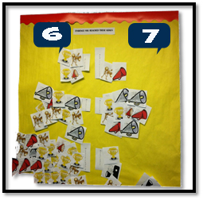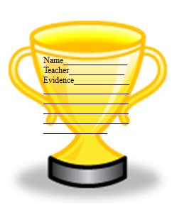

Flipped Classroom

______A flipped classroom (see Figure 32 and Figure 33b—zoom in if needed) is when your teacher records lectures for consumption as homework—before the next class session—and then dedicates class time to project-based learning supported by the homework. This approach allows you to ask questions of your teacher or collaborate with peers as you’re doing the work, rather than struggling with it at home and asking for help the next day.
______Your teacher will show you where you’ll find homework (probably on the class website or blog, or pushed out through Google Classroom) and model how to complete it.
______Likely, it will include several pieces:

- summary video prepared
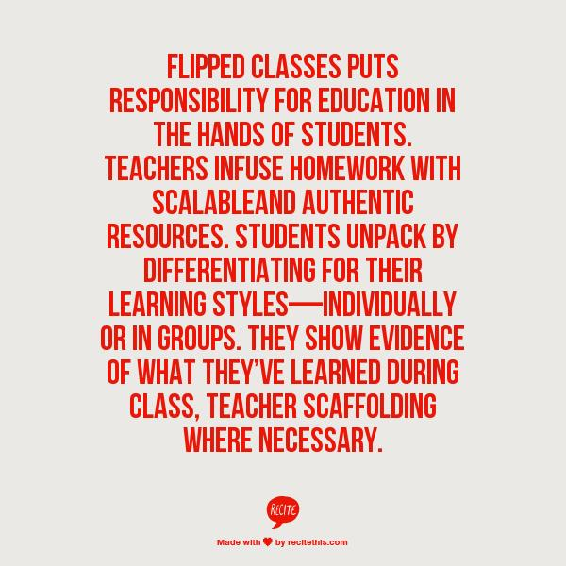
- reading material from ebooks or online sources
Figure 29--What is a flipped classroom?
- hands-on work such as keyboard practice
- preparatory steps to participate in the class project

______Tools that might be used to collect homework materials are:

- Blendspace — Figure 33a
- Google Classroom
- Google Apps
- Frolyc
- OfficeMix
- Knowmia
- LessonPaths

Figure 30a—Blendspace; 33b—Flipped classroom
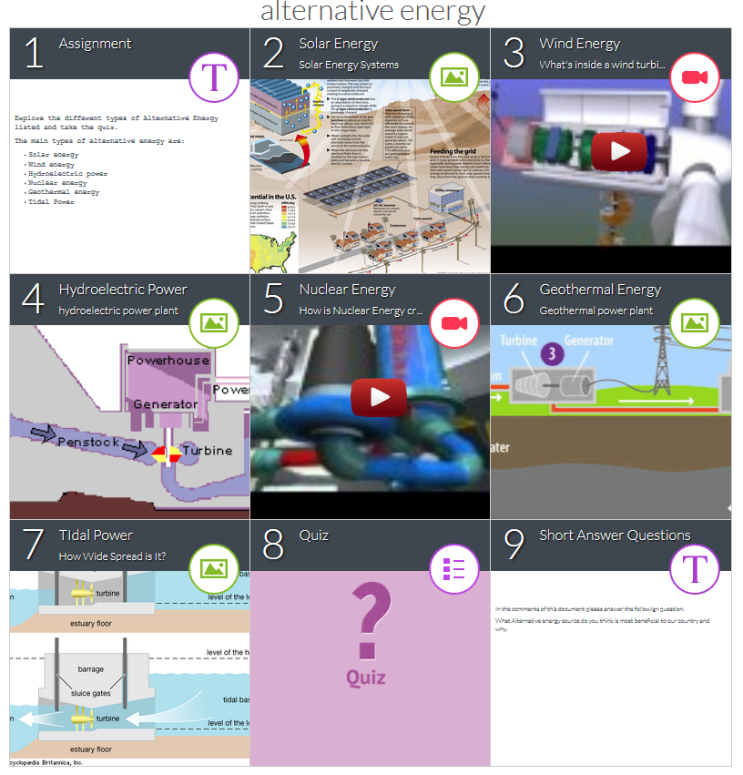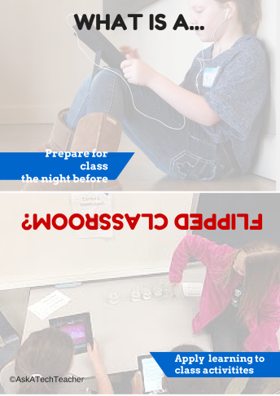

Google Apps

______Google Apps are a collection of web-based productivity applications that you can access from school or home, individually or in small groups.
______The most popular apps—and the ones you will use the most—are:

- Google Docs—for word processing projects
- Google Slides—for slideshow presentations
- Google Spreadsheets—for the analysis of data using spreadsheets
- Google Draw—for visual representation of information

______To access Google Apps requires a Google account. This will make Google Drive accessible, the core of most Google Apps.
______Take time to explore Google Drive and Google Apps before moving on.
Log-ins

______Volunteer to teach classmates how to log into digital devices and tools using user name and password (Figure 34—zoom in if needed):

Figure 31—How to log in
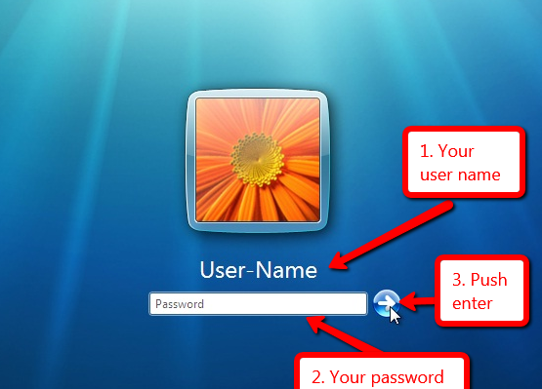

______Digital tools that might require a log-in include:

  - class etextbooks
  - keyboarding program
  - class website (with grades)
  - online webtools
  - class LMS (which likely includes your grades)

Figure 32—Track UN and PW
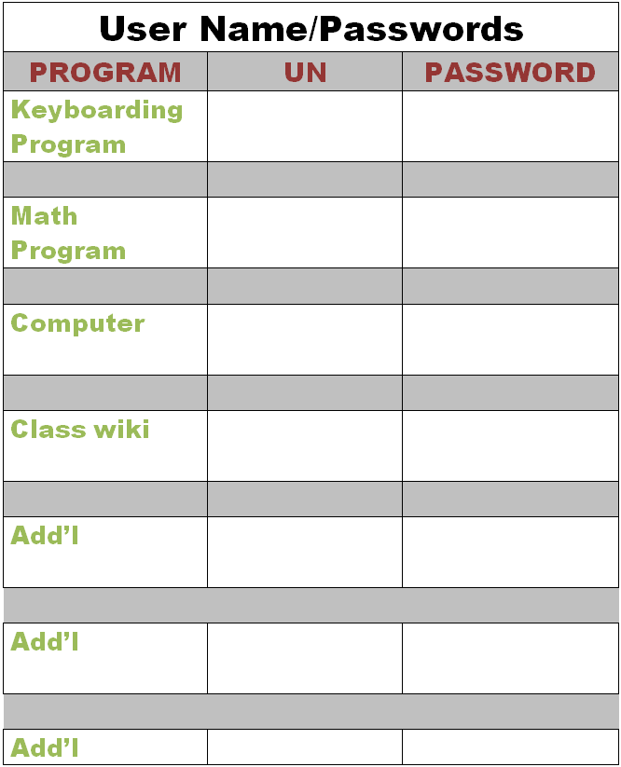
______Test the log-in for as many of your digital accounts as possible. As you do so, write the UN and PW into Figure 35 with your annotation tool.
______If you don’t want to record your log-ins in Figure 35, try one of these methods:

- Keep a physical copy in your personal binder.
- Keep a digital copy in your digital portfolio.
- Take a snapshot of it to keep on your digital device for quick reference.

______Review of log-ins is optional. Your teacher may decide you need no assistance with this and move on to the next section.

Screenshots and Screencasts

______You will use screenshot (still images) tools, apps, or add-ons (depending upon your digital device), as well as screencasts (videos) to record information from your screen. If you used the SL tech curriculum last year, you covered this thoroughly in the lesson on Screenshots and Screencasts.
______You’ll use screenshots often when you annotate assessments, rubrics, and checklists in this workbook. Once you’ve finished your notations, you’ll take a screenshot and save it to your digital portfolio or share it with your teacher. Depending upon your digital device, you might use:

    - Windows: the Snipping Tool (comes with Windows)
    - Chromebook: hold down the control key and press the window switcher key
    - Mac: Command Shift 3 to do a full screenshot and Command Shift 4 to take a partial
    - Surface tablet: hold down volume and Windows button at the same time
    - iPad: hold Home button and power button at same time
    - Online: a screenshot tool like Jing or Snagit

Figure 33a—Screenshot to explain log-in; 36b—to explain screencasts
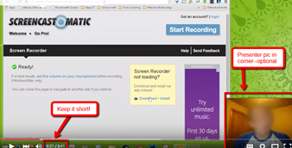

Student website

______Most teachers will select either blogs or websites, depending upon the goal:

- Blogs are more interactive and time-sensitive.
- Websites more fully cover a topic and new posts don’t push older out of the way.
______Like blogs, websites are a great way to encourage reflection, organization, logical thinking, and are a perfect place to embed shared projects, i.e., Tagxedos and Animotos.
______Websites are available with Google Apps. If your school doesn’t have Google Apps, free websites can be created at Weebly, Wix, or blog accounts like Wordpress.
______Websites should reflect your personality with your choice of colors, fonts, and layout.
______In general:

  - website and article titles pull the reader in
  - articles summarize topics with evidence and supporting links (that work)
  - tone/voice fits this type of writing and intended audience
  - at least one media is provided to support each article (picture, video, sound)
- writing purpose is clear. How is that different from tweets? Essays? Poetry?
- citations are included as needed
- occasional teamwork is exhibited

______Occasionally (several times a grading period), assess your website based on the criteria in Figure 37 (full size assessment at end of lesson):

Figure 34—Student website rubric
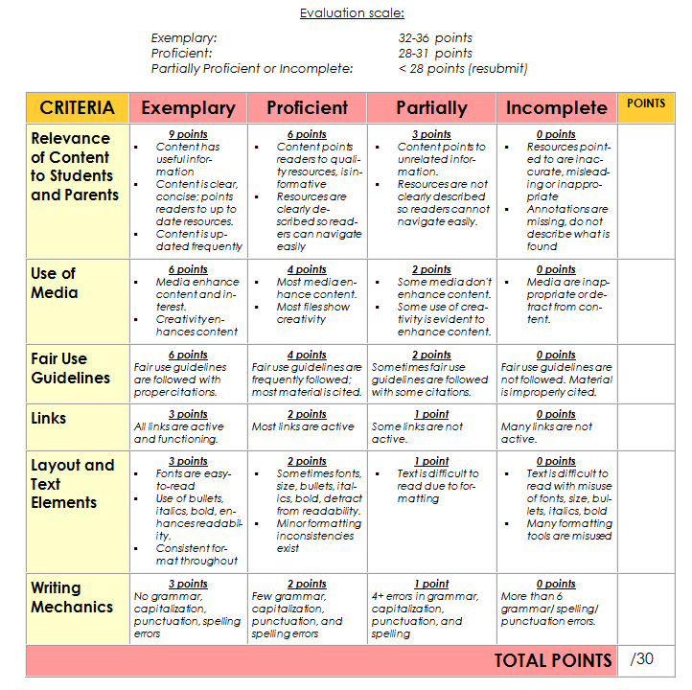
Vocabulary Decoding Tools

______As you research and read digitally, you’ll require a vocabulary decoding tool to figure out unknown words.
______Your teacher will show you how to access the native apps or webtools that accomplish this goal on the digital devices. Depending upon the device, these will be on the homepage, the browser toolbar, a shortkey, or a right click. Volunteer to demonstrate how to quickly look up words rather than skipping content.
______Options include:

- right click in MS Word and select ‘Look up’
- right click in Google Apps (i.e., Google Docs) and select ‘research’
- an online resource like Dictionary.com
- a browser app or plug-in

______Practice with several of the words in this lesson’s Vocabulary list.

Class exit ticket: Send a well-constructed email, tweet, or comment to a classmate and reply to one you receive.

Extension:
- Explore inside computer.
- Click here for discussion on using Padlet.
- What’s PollDaddy? Watch this video.
- What’s Evernote? Watch this video.
- For more Google Apps, try these:

    - Map Maker: Create a map, or update a map of a specific destination.
    - Scholar: Research and analyze sources from books, websites, other.
    - Tour Builder: Create an online tour of anywhere in world.
    - Translate: Get a tool for any text.
    - YouTube EDU: Access and view educational content.

Assessment 1—Parts of the computer
HARDWARE—PARTS OF THE COMPUTER

Student name: ___________________________________________________
Name each part of computer hardware system and whether it’s INPUT or OUTPUT. Spelling must be correct to get credit

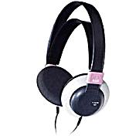
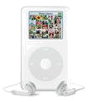

Assessment 2—Parts of the smartphone
HARDWARE—PARTS OF THE SMARTPHONE
Adapt this to your needs

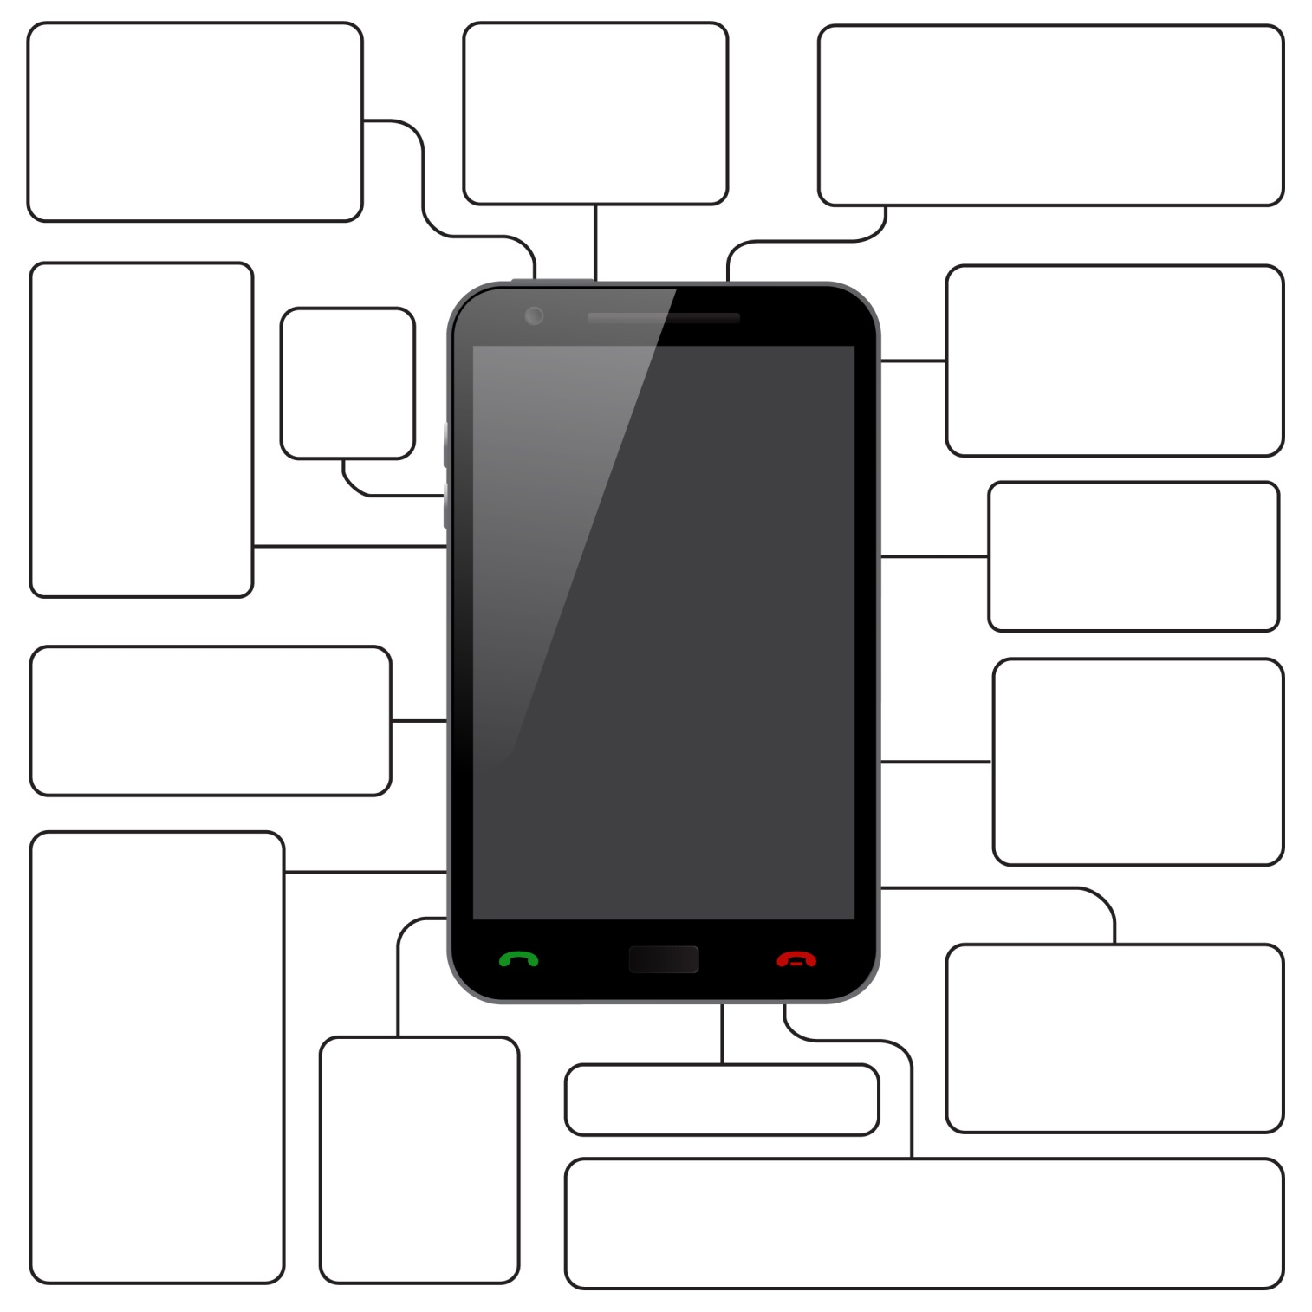
Assessment 3—Parts of an iPad
Parts of an iPad

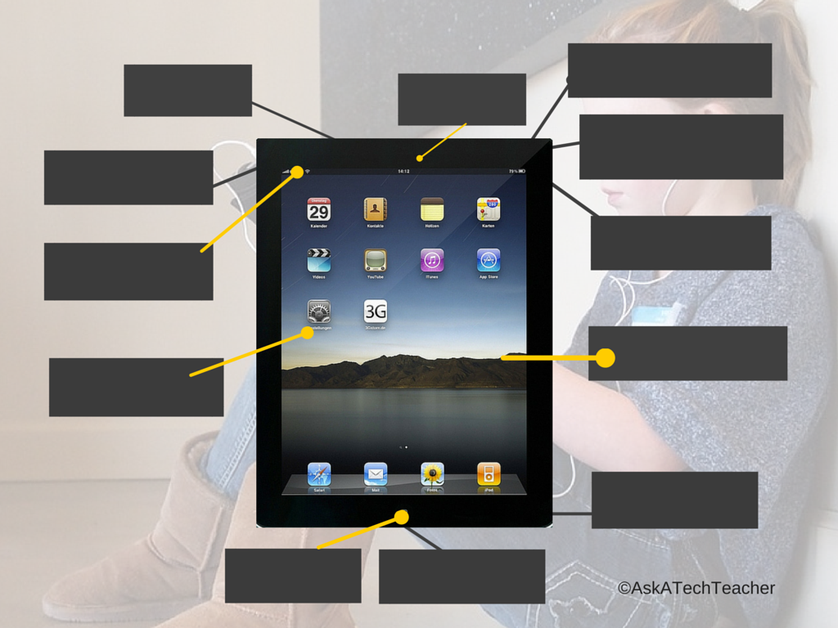
Assessment 4—Chromebook parts
Parts of a Chromebook
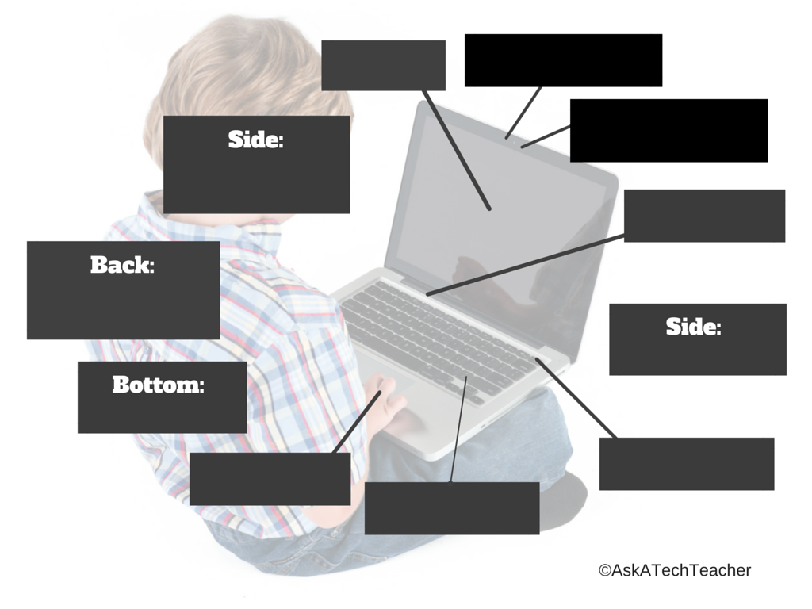
Assessment 5—Student blogging agreement
Seventh Grade Blogging Rules
(adapted from Academy of Discovery wiki)

- I will not give out any information more personal than my first name
- I will not plagiarize; instead I will expand on others' ideas and give credit where it is due.
- I will use language appropriate for school.
- I will always respect my fellow students and their writing.
- I will only post pieces that I am comfortable with everyone seeing.
- I will use constructive/productive/purposeful criticism, supporting any idea, comment, or critique I have with evidence.
- I will take blogging seriously, posting only comments and ideas that are meaningful and that contribute to the overall conversation.
- I will take my time when I write, using formal language (not text lingo), and I will try to spell everything correctly.
- I will not bully others in my blog posts or in my comments.
- I will only post comments on posts that I have fully read, rather than just skimmed.
- I will not reveal anyone else's identity in my comments or posts.

Any infraction of the Blogging Rules may result in loss of blogging privileges and an alternative assignment will be required.

Student Signature __________________________________ Date _____

Assessment 6—Blog grading rubric
Student Blog Rubric
Adapted from University of Wisconsin-Stout

CRITERIA | Exemplary | Proficient | Partial | Incomplete | POINTS
Relevance of Content to Students and Parents | 9 points  - Content has useful information  - Content is clear, concise; points readers to up to date resources.  - Blog is updated frequently | 6 points  - Content points readers to quality resources, is informative  - Resources are clearly described so readers can navigate easily | 3 points  - Content points to unrelated information.  - Resources are not clearly described so readers cannot navigate easily. | 0 points  - Resources pointed to are inaccurate, misleading or inappropriate  - Annotations are missing, do not describe what is found
Use of Media | 6 points  - Media enhance content and interest.  - Creativity enhances content | 4 points  - Most media enhance content.  - Most files show creativity | 2 points  - Some media don’t enhance content.  - Some use of creativity is evident to enhance content. | 0 points  - Media are inappropriate or detract from content.
Fair Use Guidelines | 6 points  Fair use guidelines are followed with proper citations. | 4 points  Fair use guidelines are frequently followed; most material is cited. | 2 points  Sometimes fair use guidelines are followed with some citations. | 0 points  Fair use guidelines are not followed. Material is improperly cited.
Links | 3 points  All links are active and functioning. | 2 points  Most links are active | 1 point  Some links are not active. | 0 points  Many links are not active.
Layout and Text Elements | 3 points  - Fonts are easy-to-read  - Use of bullets, italics, bold, enhances readability.  - Consistent format throughout | 2 points  - Sometimes fonts, size, bullets, italics, bold, detract from readability.  - Minor formatting inconsistencies exist | 1 point  - Text is difficult to read due to formatting | 0 points  - Text is difficult to read with misuse of fonts, size, bullets, italics, bold  - Many formatting tools are misused
Writing Mechanics | 3 points  No grammar, capitalization, punctuation, spelling errors | 2 points  Few grammar, capitalization, punctuation, and spelling errors | 1 point  4+ errors in grammar, capitalization, punctuation, and spelling | 0 points  More than 6 grammar/ spelling/ punctuation errors.
TOTAL POINTS |  |  |  |  | /30
Assessment 7—Website grading rubric
Student Website Rubric
Adapted from University of Wisconsin-Stout

CRITERIA | Exemplary | Proficient | Partially | Incomplete | POINTS
Relevance of Content to Students and Parents | 9 points  - Content has useful information  - Content is clear, concise; points readers to up to date resources.  - Content is updated frequently | 6 points  - Content points readers to quality resources, is informative  - Resources are clearly described so readers can navigate easily | 3 points  - Content points to unrelated information.  - Resources are not clearly described so readers cannot navigate easily. | 0 points  - Resources pointed to are inaccurate, misleading or inappropriate  - Annotations are missing, do not describe what is found
Use of Media | 6 points  - Media enhance content and interest.  - Creativity enhances content | 4 points  - Most media enhance content.  - Most files show creativity | 2 points  - Some media don’t enhance content.  - Some use of creativity is evident to enhance content. | 0 points  - Media are inappropriate or detract from content.
Fair Use Guidelines | 6 points  Fair use guidelines are followed with proper citations. | 4 points  Fair use guidelines are frequently followed; most material is cited. | 2 points  Sometimes fair use guidelines are followed with some citations. | 0 points  Fair use guidelines are not followed. Material is improperly cited.
Links | 3 points  All links are active and functioning. | 2 points  Most links are active | 1 point  Some links are not active. | 0 points  Many links are not active.
Layout and Text Elements | 3 points  - Fonts are easy-to-read  - Use of bullets, italics, bold, enhances readability.  - Consistent format throughout | 2 points  - Sometimes fonts, size, bullets, italics, bold, detract from readability.  - Minor formatting inconsistencies exist | 1 point  - Text is difficult to read due to formatting | 0 points  - Text is difficult to read with misuse of fonts, size, bullets, italics, bold  - Many formatting tools are misused
Writing Mechanics | 3 points  No grammar, capitalization, punctuation, spelling errors | 2 points  Few grammar, capitalization, punctuation, and spelling errors | 1 point  4+ errors in grammar, capitalization, punctuation, and spelling | 0 points  More than 6 grammar/ spelling/ punctuation errors.
TOTAL POINTS |  |  |  |  | /30

Assessment 8—Digital portfolio rubric
Digital Portfolio Rubric

CATEGORY | Exemplary | Proficient | Developing | Unsatisfactory | RATING
Selection of Artifacts | All artifacts and work samples are clearly and directly related to the purpose of portfolio. | Most artifacts and work samples are related to the purpose of the digital portfolio. | Some of the artifacts and work samples are related to the purpose of the digital portfolio. | None of the artifacts and work samples is related to the purpose of portfolio.
Reflections | All reflections clearly describe growth and achievement, and include goals for continued learning (long and short term). | Most reflections describe growth and include goals for continued learning. It is clear student put thought into writing. | A few of the reflections describe growth and include goals for continued learning. It is not clear student put thought into writing. | None of the reflections describe growth or goals for continued learning. It is clear student put little thought into writings.
Use of Multimedia | Photographs, graphics, audio and/or video files enhance concepts, ideas and relationships, create interest, and are appropriate for chosen purpose. | Most graphic elements and multimedia contribute to concepts, ideas and relationships, enhance the written material and create interest. | Some of the graphic elements and multimedia do not contribute to concepts, ideas and relationships. | Multimedia doesn’t contribute to concepts, ideas and relationships. The inappropriate use of multimedia detracts from content.
Documentation & Copyright | All media and text follow copyright guidelines. All content displays appropriate copyright permissions. | Most images, media and text created by others are cited with accurate, properly formatted citations. | Some images, media or text created by others are not cited with accurate, properly formatted citations. | No images, media or text created by others are cited with accurate, properly formatted citations.
Ease of Navigation | Navigation links are intuitive. Portfolio parts are labeled, clearly organized and allow reader to easily locate an artifact. | Navigation links generally function well, but it is not always clear how to locate an artifact or move to related pages or different section. | Navigation links are confusing and it is often unclear how to locate an artifact or move to related pages or section. | Navigation links are confusing, and it is difficult to locate artifacts and move to related pages or a different section.
Layout and Text Elements | Digital portfolio is easy to read. Fonts and type size vary appropriately for headings, sub-headings and text. Use of font styles (italic, bold, underline) is consistent and improves readability. | Digital portfolio is generally easy to read. Fonts and type size vary appropriately for headings, sub-headings and text. Use of font styles (italic, bold, underline) is generally consistent. | Digital portfolio is often difficult to read due to inappropriate use of fonts and type size for headings, sub-headings and text or inconsistent use of font styles (italic, bold, underline). | Digital portfolio is difficult to read due to inappropriate use of fonts, type size for headings, subheadings and text, and font styles (italic, bold, underline).
Captions | All artifacts are accompanied by a caption that clearly explains importance of item including title, author, and date. | Most artifacts are accompanied by a caption that clearly explains importance of item including title, author, and date. | Some artifacts are accompanied by caption that explains importance of item including title, author, and date. | No artifacts are accompanied by a caption that explains importance of item.
Writing Mechanics | There are no errors in grammar, capitalization, punctuation, and spelling. | There are few errors in grammar and spelling. These require minor editing and revision. | There are four or more errors in grammar and spelling requiring editing and revision. | There are more than six errors in grammar and spelling requiring major editing.
Lesson #4 Problem Solving

Vocabulary | Problem solving | Homework
- Cerebral  - Context  - Delineate  - Evidence  - Fail  - Sequence  - Shortkeys  - Strategic  - Task | - I can’t solve problem (what strategies have you tried?)  - I don’t like method I picked. (why?)  - Sign-up website doesn’t work (use your problem-solving strategies)  - I didn’t finish homework (why?)  - Did poorly on ** (Mulligan Rule)  - I know how to solve all problems listed (that’s OK—you’ll learn) | Assigned prior week:  Review word processing, quotes, problem-solving strategies  Select problem/date for Problem-solving Board  Keyboard 45minutes, 15 minutes at a time
How does tech solve problems?

- Previewed required material; came prepared
- Signed up for Board
- Worked well in a group
- Completed warm-up, exit ticket
- [tried to] solve own problems
- Decisions followed class rules
- Higher order thinking, Habits of Mind observed
- Successfully annotated workbook
- Joined class conversations
- Left station as it was (neat and orderly)
Step-by-step

Class warm-up: Keyboard on class typing program, paying attention to posture.

This lesson is part of many lessons—not a stand-alone. Learn to consider yourself a ‘problem solver’.

______Required skill level: Personal bias for critical thinking and independent problem solving
______Questions on homework? Come to class prepared.
______Before beginning, open your backchannel device so you can fully participate.
______Discuss what it means to be a ‘problem solver’. Who do you go to when you need a problem solved? Do you believe s/he gets it right more often than others? Would you believe most people are wrong half the time?
______Problem solving is closely aligned with logical thinking, critical thinking, reasoning, and thought habits. Discuss why you should become a problem solver (hint: refer to prior point—most people you go to for assistance are wrong half the time).
______Discuss characteristics of a ‘problem solver’ (from Common Core):

- attend to precision
- value evidence
- comprehend and critique
- demonstrate independence
- make sense of problems and persevere in solving them
- use appropriate tools strategically
- understand other perspectives

______Is problem solving ‘cerebrally-stimulating? Is it fun? Why or why not? Discuss great quotes about problem solving in Figure 48 (zoom in if needed).

Figure 35—Problem-solving quotes
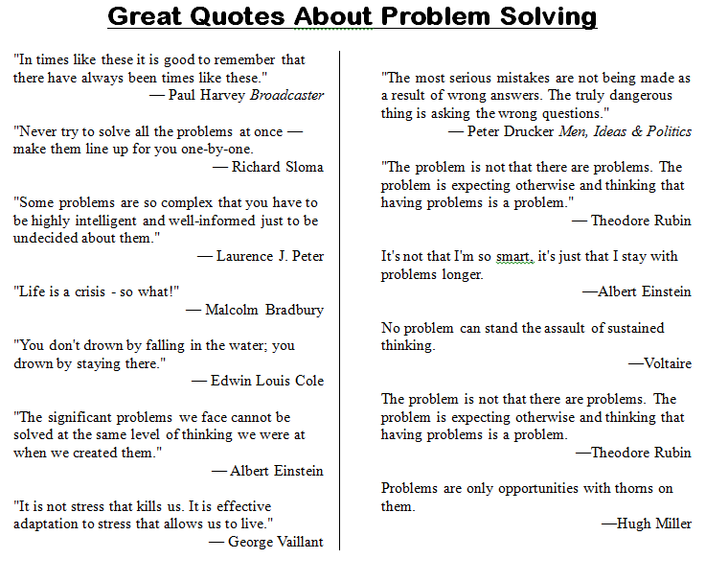

______Discuss shortkeys. How are they problem solving? Volunteer to demonstrate how you perform a skill. Is it easier to explain with the shortkey or the toolbar tool?
______Discuss problem-solving strategies (see Figure 49):

  - Act out a problem
  - Break a problem into parts
  - Distinguish between relevant and irrelevant information
  - Draw a diagram
  - Guess and check
- Observe and collect data
  - See patterns
- Think logically
- Try to solve before asking for help
- Try, fail, try again
- Use Help files
- Use tools available
- Use what has worked in past
  - Work backwards

Figure 36—How to solve a problem
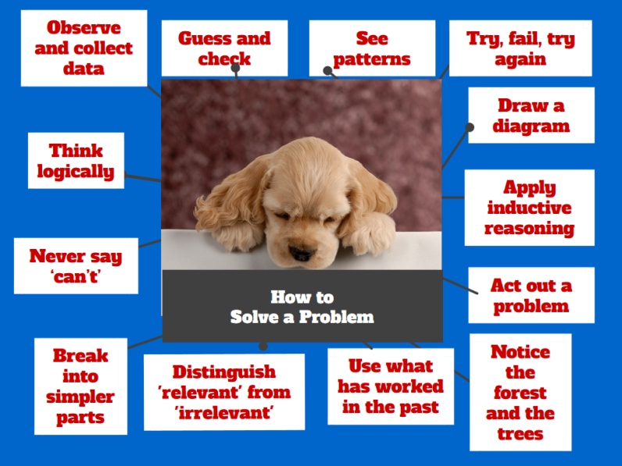

______When you face a problem, use these strategies to solve it before asking for assistance.
______This lesson includes two projects to reinforce problem solving in everyday life:

- Problem-solving Board
- Analysis of authentic problem-solving skills

Problem-solving Board

______Sign up to teach classmates common problems faced when using technology. Ideally, these were collected throughout the year—the types of problems that stopped you as you tried to use tech. Figure 50 shows what the list might include (zoom in if necessary):

Figure 37—Common tech problems
Problem
My browser is too small | I can’t find a tool
Browser toolbar missing | My screen is frozen
Can’t exit a program | My menu command is grey
What’s today’s date | Can’t find Bold, Italic
Double click doesn’t work | Can’t find the program
Start button disappeared | Internet toolbar’s gone
Program disappeared | My computer doesn’t work
Erased my document | My programs are gone

______Sign up for the Problem-solving Board via a Padlet wall embedded into the class start page, SignUp Genius, a shared spreadsheet, or another method suggested by your teacher.
______Here’s how it works:

- Select a presentation date.
- Select a problem to teach classmates.
- Find a solution and teach classmates how to solve the problem.
- Take questions. The audience is responsible for making sure the speaker makes sense.

______Here’s where you can get answers:

- Help files
- Google Search
- family and friends

______You must come prepared, having researched material. You may use visual displays to clarify information, such as screenshots, screencasts, and graphics.
______Entire presentation takes about three minutes. The Assessment at the end of the lesson is a sample rubric.
______You should own these tech problems by the end of class.

Analysis of authentic problem-solving skills

______During the grading period, you must identify five-ten problems faced in any part of your life—home, school, or personal. You’ll record the problem-solving strategy you used to solve it in a collaborative spreadsheet shared with classmates. It’ll include (see Assessment 14a-b):

- what tech problem you faced
- how you solved it
- what strategy you used from the list
- additional comments

______At the end of class, it will be a resource you can draw on for future problems.
______Here’s how this works:

Assessment 9a-b—Problem-solving authentic data
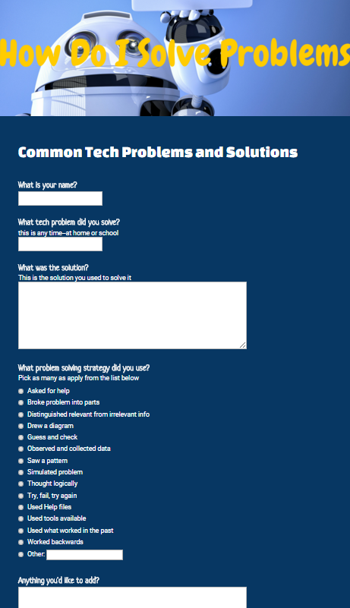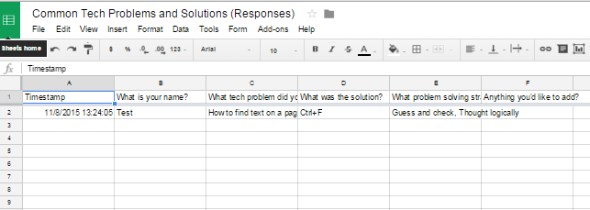
- Record 5-10 problems faced during the grading period in a Google Spreadsheet.
- Answer a Google Forms poll (like Assessment 14a).
- Complete 5-10 of these during the grading period.

______At the end of the class, collected data will be shared.

Class exit ticket: Enter one problem into the Google Form.

Extension:
- Volunteer to create Google Form.
- Present for the Problem-solving Board with video or a podcast.
- Use visual props during Problem-solving Board presentation.
- If you can’t attend class (say, parent’s car doesn’t start), present via Google Hangout (with parent permission).
- Ask to share a problem related to your education journey that isn’t on the list.

____________________________________________________________________________________________________________________________________________________________________________________________________________________________________________________________________________________________________________________________________________________________________________________________________________________________________________________________________________________________________________________________
Assessment 10—Problem-solving Presentation Assessment
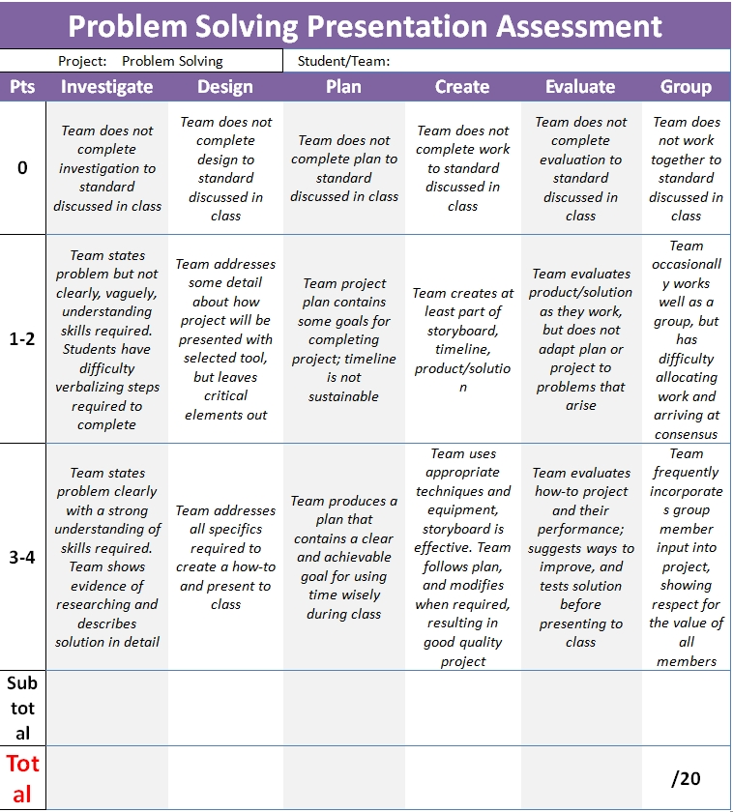
Figure 38—Common tech problems
Common Problems Students Face With Computers
 | Problem | Solution
1. | My browser is too small | Double click blue bar
2. | Browser toolbar missing | Push F11
3. | Can’t exit a program | Alt+F4
4. | What’s today’s date | Hover over clock  Shift+Alt+D in Word
5. | Double click doesn’t work | Push enter
7. | Start button disappeared | Use Windows button
8. | Program disappeared | Check taskbar
9. | Erased my document | Ctrl+Z
10. | I can’t find a tool | Right click on screen; it’ll show most common tools
11. | My screen is frozen | Clear a dialogue box  Press Escape four times
12. | My menu command is grey | Press escape 4 times and try again
13. | Can’t find Bold, Italic, Underline | Use Ctrl+B, Ctrl+I, Ctrl+U
14. | Can’t find the program | Push Start, use ‘Search’ field
15. | Internet toolbar’s gone | Push F11
16. | My computer doesn’t work | Check monitor/tower power, plugs
17. | My programs are gone | Are you logged in correctly?

Lesson #10-11 Online Image Legalities

Vocabulary | Problem solving | Homework
- Attribution  - Citation  - Copyright  - Creative Commons  - Crop  - Fair use  - Graphic  - Image  - Layer  - Macro  - Plagiarism  - Public domain  - Watermark | - Project disappeared (use search)  - There’s a watermark on picture I picked (Use one not copyrighted)  - Someone stole my artwork from my blog (options?)  - It takes a while to find the copyright information on an image (it’s not a race)  - I want to merge two pictures (be a problem solver)  - Why can’t I always use Fair Use—I’m always a student (only for educational purposes)  - Who will know I ‘borrowed’ an image? | Assigned prior week:  Review material  Watch videos to prepare for class  Draw an original piece of artwork  Practice keyboarding for 45minutes, 15 minutes at a time
Why create original artwork?

- Previewed required material
- Completed project
- Used good keyboarding habits
- Completed warm-up, exit ticket
- [tried to] solve own problems
- Decisions followed class rules
- Higher order thinking employed
- Habits of mind observed
- Successfully annotated workbook
- Joined class conversations
- Left station as it was (neat and orderly)
Step-by-step

Class warm-up: Keyboard on the class typing program, paying attention to posture.

______Required skill level: facility with using online images; understanding of the need to do that legally
______Any questions from preparatory homework?
______Before beginning, open your backchannel device so you can fully participate.
______This lesson includes three activities:

- Copyrights
- Hoaxes
- Summative Project
Copyrights
______What do you remember from last year’s discussion on image copyrights? Watch and discuss A Fair(y) Use Tale.
______Review copyright law (Figure 86 is a rephrasing).

Figure 39—Digital law—rephrased
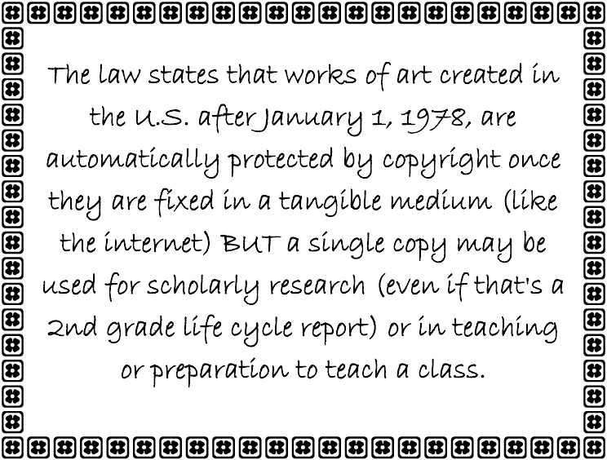

______Copyrights range from public domain—creative work can be used without permission or notification—to intensely private— available only to view, on the host website.
______When searching for images, adjust the search engine to provide only those that are in the public domain. Figure 87 shows how to find this option in Google:

Figure 40—Copyright protections on browsers
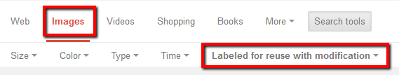

______Find several images online. Your teacher will show you how to find the copyright protections that are invariably listed on the pages. This is often time-intensive, annoying, but necessary: Never assume an image is available freely to use. If you can’t find the copyright notice, pick a different image.
______Once you’ve found the copyright information, follow the requirements. That might be ‘do nothing’, linkback, note where the picture came from with a linkback, pay a fee, or include only a linkback with no image allowed.
______Here are two examples (Figure 88—zoom in if necessary):
Figure 41—Two copyrighted images
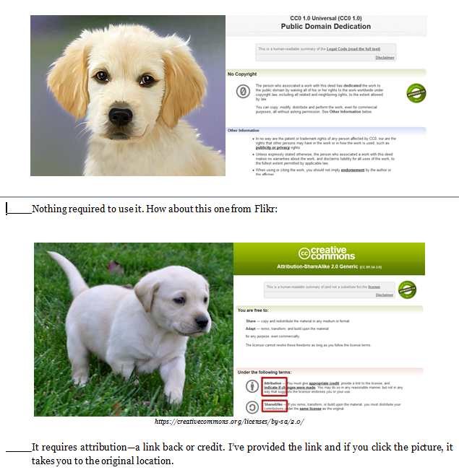

______Your teacher will show how to decode copyright protections normally included with online images. Use the Creative Commons online licensing as an example—Figures 89a-b—zoom in if needed:

Figure 42a-b—Creative Commons licensing
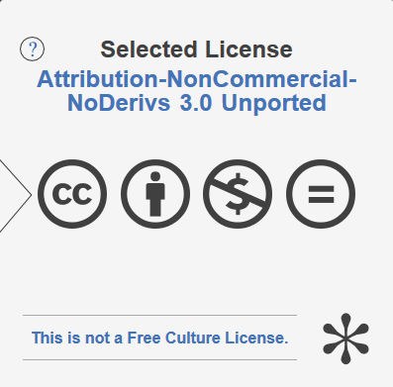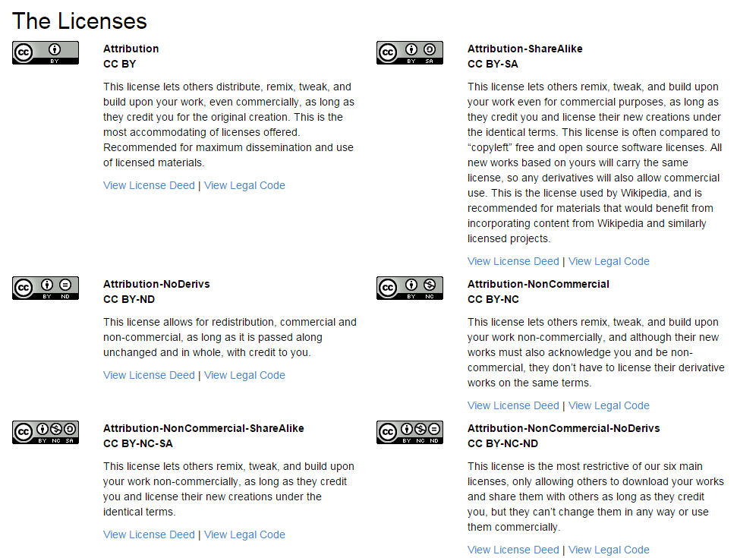
______Discuss how to cite a website. Visit EasyBib or Citation Machine.
______Some people want to share work and collaborate with others. Watch and discuss Wanna Work Together about Creative Commons licensing.
______Discuss these terms:

- Attribution
- Non derivative works
- Share alike
- Non-commercial

______Figure 90a was drawn by an artist and posted to her/his public website for sale. Without her/his knowledge, it was used forty-seven times (Figure 90b), not always in places s/he or her/his parents would approve.
______It’s easy to find where an image has been used online. All you do is drag-drop the image into Images.google.com or upload it to Tineye. They do the search for you.
______What could they do in the future? How about add a copyright notice to the website, announcing that all media contained on the website are protected by copyright laws and cannot be used without permission.

Figure 43a-b—Artistic work online
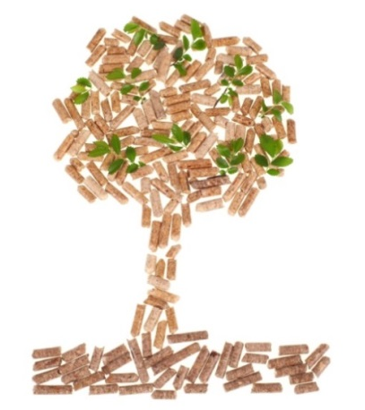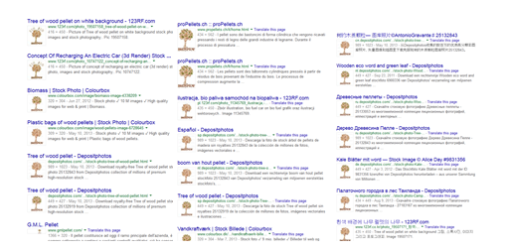

______What is Fair Use (Figure 91):

Figure 44—Definition of 'fair use'
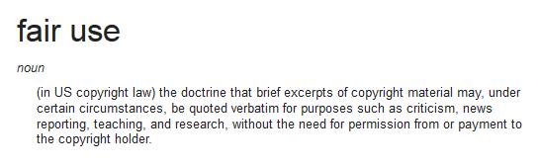

______It provides rights to use images for purposes such as education without obtaining permission from creator. How does ‘fair use’ apply to your school research?
______Anyone want to be an artist, writer, journalist, or other profession that relies on creativity? How might copyright law be important to you?
______Consider the drawing you completed for homework. How would you feel if someone stole it? What if thief posted it online? What if they made ugly comments about it? What if they made money off of it and didn’t share it with creator. What if you really needed that money to go to college?
______When must you credit material found online? In general terms:

- facts not commonly known or accepted
- exact words and/or unique phrase
- reprint of diagrams, illustrations, charts, pictures, or other visual materials
- opinions that support research

Hoaxes

______Discuss how easy it is to fake a picture with programs like Photoshop.
______In Figures 92a-b: Was the tree added to or erased from the original photo? Zoom in if needed.

Figure 45a-b: Add or remove pieces from a photo

______Look at Figure 93. Did President Roosevelt really ride a moose across a river?

Figure 46—Real or a hoax?
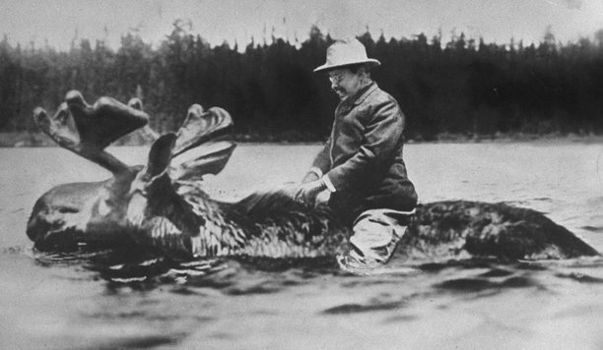

______Discuss as a class whether Figures 94a-c are accurate—and how do you know? It’s no surprise photos are not accepted as proof in court.
Figure 47a-c—Real or hoax pictures?

______Visit this website. Is it real? How do you know?
______Watch ‘War of the Worlds’—a famous video hoax. Discuss how it confused fiction with reality if listeners missed the first ten minutes.

Summative Project

______Conclusion: It’s a lot easier to create your own graphics than use someone else’s.
______Open school’s graphic program. Draw a picture that collaborates with a class inquiry.

______When done, take a screen shot and share on blog/website.

Class exit ticket: Using Twitter, class Discussion Board, or blog, share your thoughts about copyrights and how they protect your creative genius.

Extension:
- Do Webquest Hoax or Not and discuss.
- Find five copyright-free, public domain images to support a project you are working on for another class (history, science, literacy, Language B):

- one from a public domain website
- one from Google images (that is legal to use)
- one created in a word processing program
- one created in Paint, KidPix, or another drawing program
- one created in Photoshop (if you have learned this program)

- Create a blog post that includes images from classmates. Provide proper credit.
- Visit class Internet start page for websites tied to inquiry.

More from Structured Learning
More
If you’re looking for other student workbooks that accompany the
K-8 technology curriculum, try these:

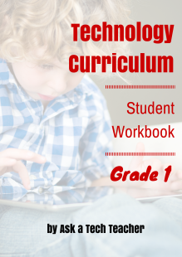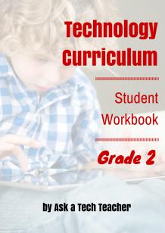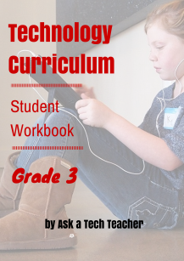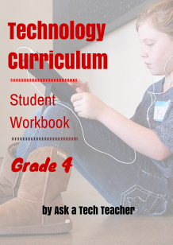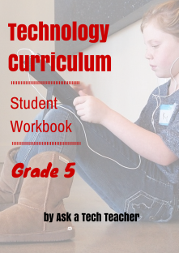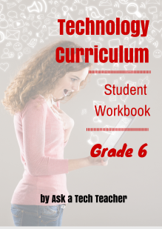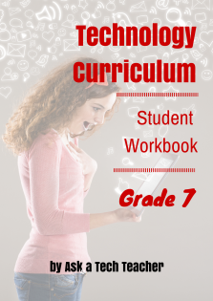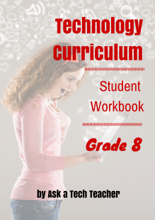

Ask your teacher how you can use this ebook on:

IPads… PCs… iMacs… Laptops… Macbooks… Netbooks… Chromebooks… Smartphones… At home
